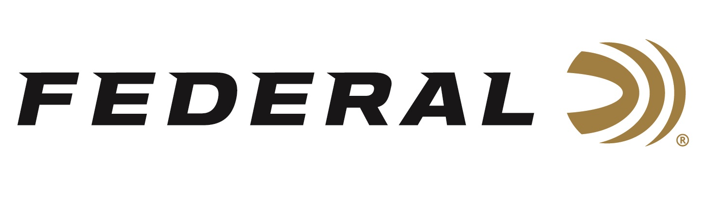

FOR IMMEDIATE RELEASE

Federal Will Showcase New Products at Industry Leading Conservation Shows in February

ANOKA, Minnesota – February 12, 2020 – Federal Ammunition recently announced more than 130 individual product SKUs in more than 34 cataloged product lines during the 2020 SHOT Show this past January in Las Vegas, Nevada. Now the company is set to exhibit and showcase many of these new products to customers at three large conservation-driven shows in February.

Federal Ammunition is the presenting sponsor of the 2020 National Pheasant Fest & Quail Classic at the Minneapolis Convention Center in Minneapolis, Minnesota
February 14-16. Federal’s new product highlight at this show will feature Prairie Storm sub-gauge loads. Four new 16- and 28-gauge loads use the updated FLITECONTROL FLEX wad and a mixed payload of standard pellets and FLITESTOPPER lead to produce full, consistent patterns.

Federal Ammunition will exhibit at the Western Hunting & Conservation Expo located at the Salt Palace Convention Center in Salt Lake City, Utah, February 13-16. Federal’s new product highlight at this show will be Terminal Ascent. Its bonded construction penetrates deep, while the patented Slipstream polymer tip initiates expansion even at lower velocities and long range. AccuChannel groove technology improves accuracy and minimizes drag. Available in eleven of the most popular hunting cartridges and as component bullets.

Federal’s turkey loads, and much more will be on display at the 44th Annual National Wild Turkey (NWTF) Convention & Sport Show at the Gaylord Opryland Resort and Convention Center in Nashville, Tennessee, February 13-15. Federal’s new product highlight at this show will be MeatEater Series Ammunition. Federal has partnered with conservationist, chef, author and hunter Steven Rinella on an exclusive new line of ammunition, featuring Trophy Copper rifle ammunition, 3rd Degree turkey loads and all-new Federal Premium Bismuth shotshells.

All these new products, and many more, will be on display at Federal’s booth for customers to view and learn full details. Attendees are encouraged to stop by and talk about new products and all things ammunition with company representatives.
Federal ammunition can be found at dealers nationwide or purchased online direct from Federal. For more information on all products from Federal or to shop online, visit www.federalpremium.com.

Press Release Contact: JJ Reich
Senior Manager – Press Relations
E-mail: VistaPressroom@VistaOutdoor.com

About Federal Ammunition
Federal, headquartered in Anoka, MN, is a brand of Vista Outdoor Inc., an outdoor sports and recreation company. From humble beginnings nestled among the lakes and woods of Minnesota, Federal Ammunition has evolved into one of the world's largest producers of sporting ammunition. Beginning in 1922, founding president, Charles L. Horn, paved the way for our success. Today, Federal carries on Horn's vision for quality products and service with the next generation of outdoorsmen and women. We maintain our position as experts in the science of ammunition production. Every day we manufacture products to enhance our customers' shooting experience while partnering with the conservation organizations that protect and support our outdoor heritage. We offer thousands of options in our Federal Premium and Federal lines-it's what makes us the most complete ammunition company in the business and provides our customers with a choice no matter their pursuit.

