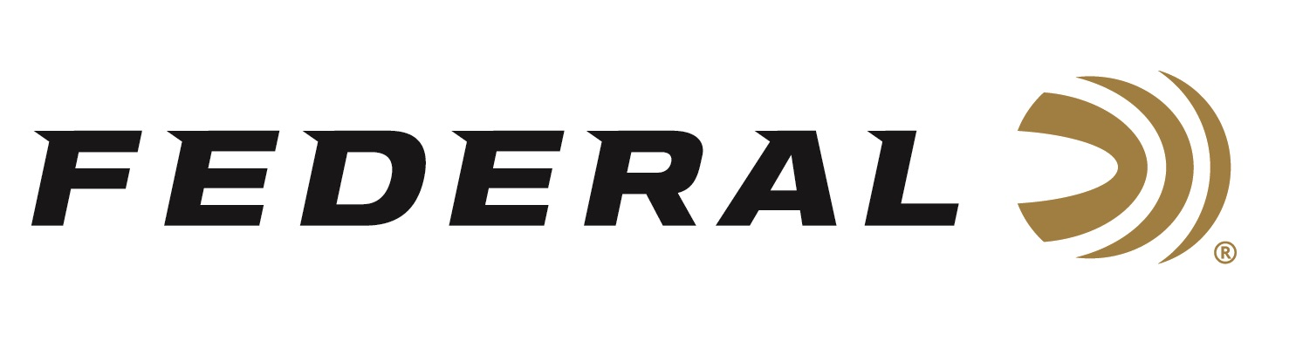

FOR IMMEDIATE RELEASE

Federal to Launch New Products at the 2022 SHOT Show

ANOKA, Minnesota – January 13, 2022 – Federal Ammunition will announce a number of new product offerings during the 2022 SHOT Show (Booth No. 11838), January 18-21 at the Sands Expo Center in Las Vegas, Nevada.

“Being the largest ammunition manufacturer isn’t just boasting. It matters, because it allows Federal to deliver the widest range of new products to our customers every year,” said Federal’s President Jason Vanderbrink. “This year, Federal will continue to introduce new loads and components to the marketplace. This means hunters and shooters of all stripes can get the new products that best meets their needs and interests.”

New for 2022 product launch highlights include:

30 Super Carry - Shooting’s biggest cartridge introduction in decades is getting off to a powerful start with Federal Premium HST Personal Defense ammo and American Eagle training rounds.

High Over All - Engineered for the most elite trap, skeet and sporting clays shooters, Federal Premium High Over All leaves a trail of shattered targets in its wake and more reloads per shell. It’s the ultimate competition load for the world’s best shooters.

Force X2 Shorty - Federal has combined the power of two new technologies to create a shotshell option that changes the nature of self-defense. Force X2 Shorty shells measure just 1 ¾ inches but hold a payload of six 00 segmenting buckshot engineered to split into two equal pieces on impact.

HammerDown – Federal is opening up the performance and power of HammerDown to hunters who shoot 35 Rem. and 444 Marlin. The geometry of each round’s case, bullet and cartridge ensures flawless cycling through tubular magazine and typical lever-action feeding systems.

Top Gun with Paper Wad - Experience the clay-crushing performance of one of our most trusted target loads and leave less plastic downrange. Select Federal Top Gun offerings combine the new Paper Wad, cellulose-based filler and a paper gas-sealing over-powder wad to maximize patterns while reducing shooters’ impact. Available in both lead and steel payload options.

HST - Fuel magnum revolvers with the power of Federal Premium HST thanks to new offerings in 357 Magnum and 327 Magnum. The proven bullet design fully utilizes the magnum performance of these cartridges to maximize expansion and hit critical penetration depths.

Punch - Shooters who choose to protect themselves with the powerful 44 S&W Spl. can now opt for the versatility of Federal Punch. Like all loads in the line, the 180-grain offering was developed using Federal Ammunition’s decades of experience designing the world’s finest defensive handgun loads.

All these new products, and many more will be on display at Booth No. 11838 for customers to view and learn full details. Learn more at Federal and all its ammunition products at: www.federalpremium.com.

Press Release Contact: JJ Reich
Senior Manager – Press Relations
E-mail: VistaPressroom@VistaOutdoor.com

About Federal Ammunition
Federal, headquartered in Anoka, MN, is a brand of Vista Outdoor Inc., an outdoor sports and recreation company. From humble beginnings nestled among the lakes and woods of Minnesota, Federal Ammunition has evolved into one of the world's largest producers of sporting ammunition. Beginning in 1922, founding president, Charles L. Horn, paved the way for our success. Today, Federal carries on Horn's vision for quality products and service with the next generation of outdoorsmen and women. We maintain our position as experts in the science of ammunition production. Every day we manufacture products to enhance our customers' shooting experience while partnering with the conservation organizations that protect and support our outdoor heritage. We offer thousands of options in our Federal Premium and Federal lines-it's what makes us the most complete ammunition company in the business and provides our customers with a choice no matter their pursuit.

