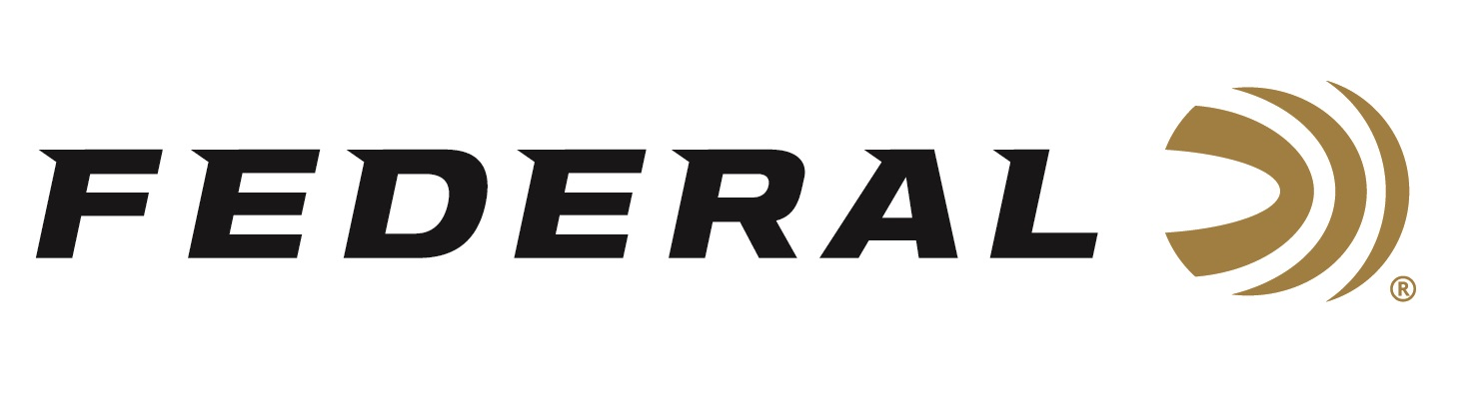

FOR IMMEDIATE RELEASE

On Target Magazine Honors Federal Premium Berger Hybrid Hunter with Editors’ Choice Award

ANOKA, Minnesota – January 8, 2020 – On Target magazine recently recognized Federal Premium Berger Hybrid Hunter with an Editors’ Choice Award for best-of-the-best in ammunition, as part of the magazine’s 18th annual awards program. These loads blend the profile of a low-drag match bullet with a traditional hunting projectile design and is available in ten of today’s most popular cartridges.

“In 2018, we announced new loads from our latest industry partner, Berger, loaded for competition shooters. The following year, we launched new hunting loads using Berger Hybrid Hunter bullets,” said Federal Centerfire Product Director Mike Holm. “Those products were received with an outstanding response from consumers worldwide. Our partnership with Berger has been great and we are very happy to see On Target editors recognize these great products as well.”

Federal Premium Berger Hybrid Hunter bullet weights have been fine-tuned to provide exceptional accuracy through any rifle. High ballistic coefficients exceed those of comparable designs thanks to a hybrid nose design that combines tangent and secant ogive features. The bullets are loaded with our finest nickel-plated brass, Gold Medal® primers and specially formulated propellant for the best consistency and reliability. Other features include superior accuracy across a wide range of firearms, lethal and reliable terminal performance on medium and big game, and more.

On Target is one of the leading publications in the shooting sports industry. Its staff tests and reviews guns, ammunition and hunting products, and presents the results in a straightforward, no-nonsense format that provides all the information consumers need to make purchase decisions. The print version of On Target can be picked up free at any of the nearly 2,000 firearm and hunting product retailers nationwide that distribute the magazine.

The On Target Editors’ Choice Awards are reserved for the best of the best new products—those which demonstrate outstanding technical achievement or represent an extraordinary value for the money.

For more information on all products from Federal, visit www.federalpremium.com.

Press Release Contact: JJ Reich
Senior Communications Manager - Ammunition
E-mail: VistaPressroom@VistaOutdoor.com

About Federal Ammunition
Federal, headquartered in Anoka, MN, is a brand of Vista Outdoor Inc., an outdoor sports and recreation company. From humble beginnings nestled among the lakes and woods of Minnesota, Federal Ammunition has evolved into one of the world's largest producers of sporting ammunition. Beginning in 1922, founding president, Charles L. Horn, paved the way for our success. Today, Federal carries on Horn's vision for quality products and service with the next generation of outdoorsmen and women. We maintain our position as experts in the science of ammunition production. Every day we manufacture products to enhance our customers' shooting experience while partnering with the conservation organizations that protect and support our outdoor heritage. We offer thousands of options in our Federal Premium and Federal® lines-it's what makes us the most complete ammunition company in the business and provides our customers with a choice no matter their pursuit.

###

