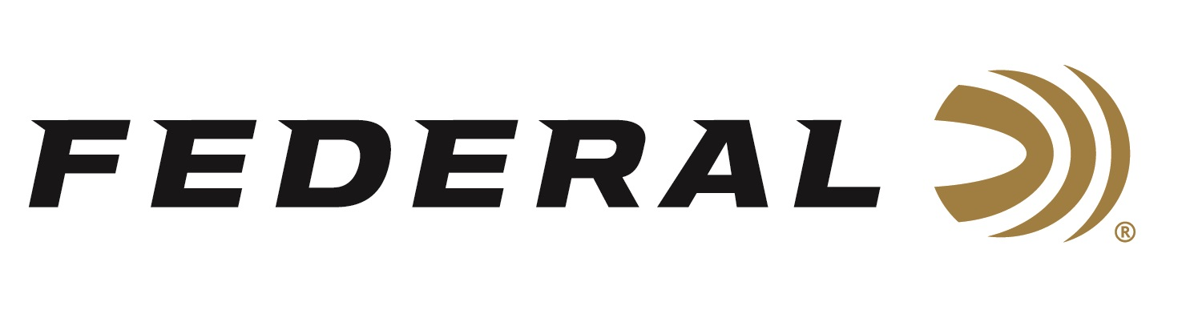

FOR IMMEDIATE RELEASE

The Federal Premium Black Cloud TSS Product Lineup Increases
with a 20-Gauge Option

ANOKA, Minnesota – February 6, 2020 – Federal Premium Black Cloud, the deadliest load in waterfowl hunting, continues to add new options with its 2020 release of 20-gauge Black Cloud TSS.

“The new Black Cloud TSS carries on a lethal legacy, blending proven FLITESTOPPER Steel pellets and 18 g/cc Tungsten Super Shot,” said Federal Shotshell Product Manager Dan Compton. “New for 2020, waterfowl hunters can get that same performance in a new 20-gauge load that blends No. 3 FLITESTOPPER Steel with No. 9 TSS.”

The new Black Cloud TSS recipe blends 60 percent HEAVYWEIGHT TSS pellets (instead of the traditional steel) and 40 percent FLITESTOPPER steel. These high-end loads feature No. 7 or No. 9 TSS mixed with BB or No. 3 FLITESTOPPER steel. The loads also feature Federal’s lead-free Catalyst primers and clean, fast-burning propellant. The FLITECONTROL FLEX wad provides the most consistent patterns in all types and port-styles of chokes. The new Black Cloud TSS extends effective range past 50 yards.

Federal Premium Black Cloud has reigned as waterfowl hunting’s deadliest load for a decade. During that time, its FLITECONTROL wad and famous FLITESTOPPER pellets have earned a reputation for reliably delivering downrange devastation in any situation. But, Federal’s team of engineers did not let the product line rest. They continue to improve the list of options and the loads’ recipes. During the past few years, the team improved the product, upgrading many of its components and introducing the FLITECONTROL FLEX wad that performs great with any style of choke. Black Cloud’s lethal configuration is better than ever, offering sizeable gains in pattern density and killing power while slashing variations in velocity and reducing barrel residue.

The industry continues to honor Black Cloud for its time-tested innovation and performance. Field & Stream magazine recently recognized this Black Cloud TSS load with an Editors’ Choice honor for Best-of-the-Best in ammunition, as part of the magazine’s Field Test Buyer’s Guide in the December 2019 – January 2020 issue.

“With No. 9 Tungsten Super Shot blended with FLITESTOPPER steel, Black Cloud TSS delivers forgiving patterns and long-range thump unlike any duck load I’ve ever tried,” stated Hunting Editor Will Brantley in the article.

TSS is a metal alloy comprised primarily of tungsten. It has a density of 18 grams per cubic centimeter and is harder than steel. TSS is more than double the density of steel and 50 percent denser than lead. The increased density retains velocity and penetrates deep. Hardness also prevents pellet deformation, which improves pattern efficiency and penetration. Because of its increased density, you can use a smaller TSS pellet to deliver the same amount of energy as much larger lead shot or steel shot. This means you can greatly increase the pellet count of a payload by using a smaller shot size. TSS is also certified non-toxic by the US Fish and Wildlife Service, so it can be used for waterfowl hunting.

The new 3-inch, 20-gauge option has a 1-ounce payload No. 3 FS Steel and No. 9 TSS. Two 12-gauge, 3-inch Federal Premium Black Cloud TSS loads are offered. The first load option is 1-¼ ounce BB FS Steel mixed with No. 7 TSS. The second load is 1-¼ ounce No. 3 FS Steel blended with No. 9 TSS. All are available in 10-count boxes.

Federal ammunition can be found at dealers nationwide or purchased online direct from Federal. For more information on all products from Federal or to shop online, visit www.federalpremium.com.

Press Release Contact: JJ Reich
Senior Communications Manager - Ammunition
E-mail: VistaPressroom@VistaOutdoor.com

About Federal Ammunition
Federal, headquartered in Anoka, MN, is a brand of Vista Outdoor Inc., an outdoor sports and recreation company. From humble beginnings nestled among the lakes and woods of Minnesota, Federal Ammunition has evolved into one of the world's largest producers of sporting ammunition. Beginning in 1922, founding president, Charles L. Horn, paved the way for our success. Today, Federal carries on Horn's vision for quality products and service with the next generation of outdoorsmen and women. We maintain our position as experts in the science of ammunition production. Every day we manufacture products to enhance our customers' shooting experience while partnering with the conservation organizations that protect and support our outdoor heritage. We offer thousands of options in our Federal Premium and Federal® lines-it's what makes us the most complete ammunition company in the business and provides our customers with a choice no matter their pursuit.

