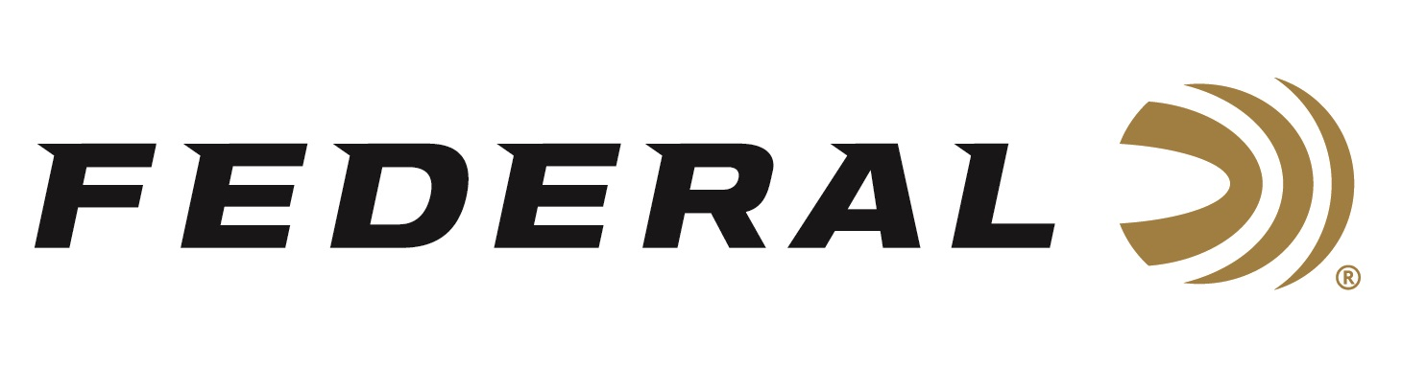

FOR IMMEDIATE RELEASE

Federal Custom Shop Now Offers Fourteen Options of Centerfire Cartridges for Big Game Hunting

ANOKA, Minnesota – May 28, 2020 – Federal Custom Shop products are for hunters and shooters who demand ammunition tailored for their individual needs at the highest level of quality, or who can’t find the right ammunition on the retail shelf. Hunters and shooters select cartridge, projectile, and grain weight, choosing from a menu of available options. Launched in the fall of 2019, the product line in the Federal Custom Shop continues to grow.

Available Custom Shop cartridge options currently include 243 Win, 257 Roberts +P, 257 Weatherby, 6.5 Creedmoor, 6.5-284 Norma, 270 Win, 270 WSM, 284 Win, 7mm Rem Mag, 308 Win, 30-06 Sprg, 300 Win Mag, 300 WSM, and 338 Federal. Customers will also be able to buy these cartridges with bullets not currently offered in Federal’s factory ammunition lineup. Examples include the Barnes Tipped TSX, Berger Hunter Hybrid, Hornady ELD-X, Nosler AccuBond, Nosler AccuBond Long Range, Nosler Partition, Sierra MatchKing, Federal Premium Terminal Ascent, and Federal Premium Trophy Copper. The specific list of available bullets varies per cartridge selected.

The Federal ammunition factory is in Anoka, Minnesota. Its online Custom Shop is a separate, secured room inside with a state-of-the-art reloading workshop focused on the utmost attention to detail, quality and care for each hand-loaded round produced. An elite group of Federal’s most experienced employees were selected to work in the Custom Shop. Using the best components available, these expert engineers handcraft this ammunition to order. Each round is hand-checked with a final cleaning and inspection before being packed in Custom Shop packaging and shipped out. Each box of Custom Shop ammunition is signed by the Federal employee who hand-loaded it.

A dedicated page on www.federalpremium.com takes Custom Shop users to an order form, where they select their ammunition options and preferences, then purchase the custom ammunition via credit card. Since ammunition is made-to-order, typical lead time is approximately 2 to 3 weeks to produce. Buyers will receive their order after a few days of shipping time.

Federal ammunition can be found at dealers nationwide or purchased online direct from Federal. For more information on all products from Federal or to shop online, visit www.federalpremium.com.
Press Release Contact: JJ Reich
Senior Manager – Press Relations
E-mail: VistaPressroom@VistaOutdoor.com

About Federal Ammunition
Federal, headquartered in Anoka, MN, is a brand of Vista Outdoor Inc., an outdoor sports and recreation company. From humble beginnings nestled among the lakes and woods of Minnesota, Federal Ammunition has evolved into one of the world's largest producers of sporting ammunition. Beginning in 1922, founding president, Charles L. Horn, paved the way for our success. Today, Federal carries on Horn's vision for quality products and service with the next generation of outdoorsmen and women. We maintain our position as experts in the science of ammunition production. Every day we manufacture products to enhance our customers' shooting experience while partnering with the conservation organizations that protect and support our outdoor heritage. We offer thousands of options in our Federal Premium and Federal® lines-it's what makes us the most complete ammunition company in the business and provides our customers with a choice no matter their pursuit.

