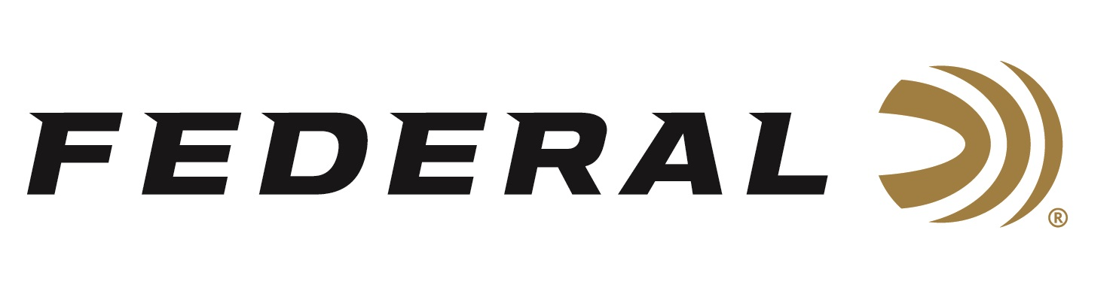

FOR IMMEDIATE RELEASE

Federal Custom Shop Turkey Loads Now in Season

ANOKA, Minnesota – March 25, 2020 – Turkey hunting seasons have started or are starting soon nationwide. The Federal Custom Shop is where hunters can select and find tungsten super shot (TSS) in hard-to-find sub-gauges and low-recoil configurations. A dedicated page on www.federalpremium.com takes Custom Shop users to an order form, where they select their ammunition options and preferences, then purchase the custom ammunition via credit card.

Federal offers a wide selection of TSS factory loads in a variety of gauge and payloads intended for turkey hunting. However, Custom Shop TSS loads are options that customers cannot find in the catalog such as a 12-gauge, 2¾-inch load, or 28-gauge or 16-gauge loads. Customers can choose their gauge, shell length, shot size and shot weight from a list of TSS options. Gauges include 10, 12, 16, 20 and 28 with shotshell length and payloads varying depending on each gauge. TSS shot size could be 7, 8, 9, and 10 or mixed 7/9 or 8/10—this also depends on gauge selected.

The Federal ammunition factory in Anoka, Minnesota, its online Custom Shop is a separate, secured room inside with a state-of-the-art reloading workshop focused on the utmost attention to detail, quality and care for each hand-loaded round produced. An elite group of Federal’s most experienced employees were selected to work in the Custom Shop. Using the best components available, these expert engineers handcraft this ammunition to order. Each round is hand-checked with a final cleaning and inspection before being packed in Custom Shop packaging and shipped out. Each box of Custom Shop ammunition is signed by the Federal employee who hand-loaded it. Since ammunition is made-to-order, typical lead time is approximately 2 to 3 weeks to produce. Buyers will receive their order after a few days of shipping time.

TSS is incredibly dense which helps it provide optimum energy and the highest velocities at long ranges. Shotshells loaded with TSS represent a big upgrade from anything previously available, letting hunters harvest gobblers farther than they ever thought possible. Payloads of No. 7, 8, 9 or 10s TSS shot provide high pellet counts—in many cases, more than double compared to lead loads of the same weight. The shot is 18 grams per cubic centimeter density and is 56 percent denser than lead.

Federal ammunition can be found at dealers nationwide or purchased online direct from Federal. For more information on all products from Federal or to shop online, visit www.federalpremium.com.
Press Release Contact: JJ Reich
Senior Manager – Press Relations
E-mail: VistaPressroom@VistaOutdoor.com

About Federal Ammunition
Federal, headquartered in Anoka, MN, is a brand of Vista Outdoor Inc., an outdoor sports and recreation company. From humble beginnings nestled among the lakes and woods of Minnesota, Federal Ammunition has evolved into one of the world's largest producers of sporting ammunition. Beginning in 1922, founding president, Charles L. Horn, paved the way for our success. Today, Federal carries on Horn's vision for quality products and service with the next generation of outdoorsmen and women. We maintain our position as experts in the science of ammunition production. Every day we manufacture products to enhance our customers' shooting experience while partnering with the conservation organizations that protect and support our outdoor heritage. We offer thousands of options in our Federal Premium and Federal® lines-it's what makes us the most complete ammunition company in the business and provides our customers with a choice no matter their pursuit.

