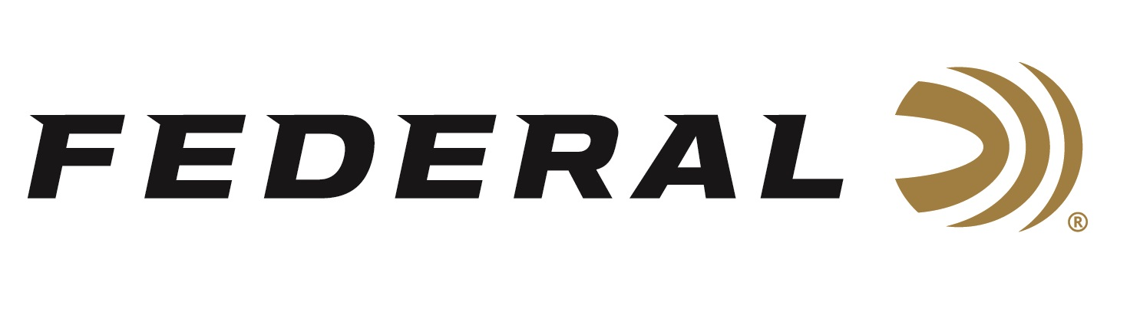

FOR IMMEDIATE RELEASE

Federal Ambassador Dakota Overland Wins the Ladies Division
at the 2020 USPSA Multigun National Championship

ANOKA, Minnesota – June 23, 2020 – Federal brand ambassador and competitive shooter Dakota Overland takes home the Ladies Division title at the recent 2020 USPSA Multigun Nationals Match in Frostproof, Florida.

“The match itself wasn’t ladies focused, however I won both the Ladies’ categories in the Tactical and Overall,” reported Overland. “I had no malfunctions, and my ammo worked flawlessly with unbeatable accuracy and reliability. Throughout my shooting career, Federal has been my ammo of choice and continues to be.”
“Dakota bested 17 other female competitors in 12 different stages over two days of competition to take top honors,” said Federal Vice President of Marketing Jason Nash. “This annual USPSA summer event attracts top multigun shooters from across the country, and for her to take home the Overall Ladies title is quite impressive. We congratulate her for a great match and representing Federal in such a big way.”

Although still in her teens, Dakota Overland is an avid hunter and ambitious competitor who regularly participates in United States Practical Shooting Association (USPSA) pistol and 3-gun matches. Her schedule, which typically includes an average of 13 major shoots each season, has taken her on a whirlwind tour of some of the country’s top ranges. Along with the thrill of rapid-fire competition, Dakota enjoys the camaraderie among shooters, as well as helping other young people get into the sport.

Federal ammunition can be found at dealers nationwide or purchased online direct from Federal. For more information on all products from Federal or to shop online, visit www.federalpremium.com.

Press Release Contact: JJ Reich
Senior Manager – Press Relations
E-mail: VistaPressroom@VistaOutdoor.com

About Federal Ammunition
Federal, headquartered in Anoka, MN, is a brand of Vista Outdoor Inc., an outdoor sports and recreation company. From humble beginnings nestled among the lakes and woods of Minnesota, Federal Ammunition has evolved into one of the world's largest producers of sporting ammunition. Beginning in 1922, founding president, Charles L. Horn, paved the way for our success. Today, Federal carries on Horn's vision for quality products and service with the next generation of outdoorsmen and women. We maintain our position as experts in the science of ammunition production. Every day we manufacture products to enhance our customers' shooting experience while partnering with the conservation organizations that protect and support our outdoor heritage. We offer thousands of options in our Federal Premium and Federal® lines-it's what makes us the most complete ammunition company in the business and provides our customers with a choice no matter their pursuit.

