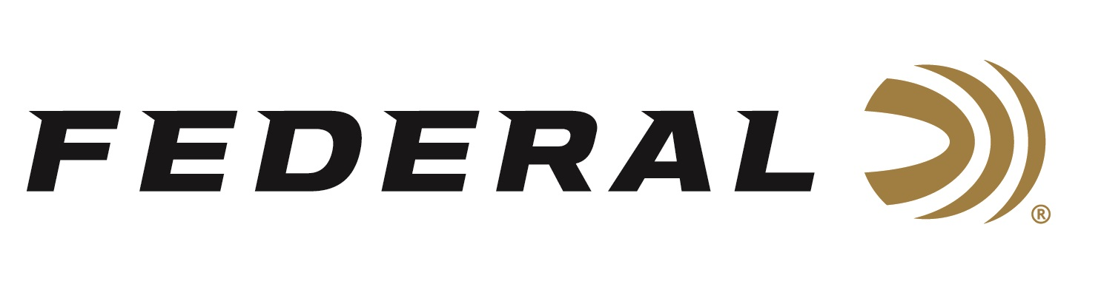
FOR IMMEDIATE RELEASE

Competitive Sporting Clays Shooter Derrick Mein Wins Kansas State Championship

ANOKA, Minnesota – June 29, 2021 – Federal Ammunition sponsored shooter Derrick Mein has won his 14th Kansas State Championship Title. The Powder Creek State Sporting Clays Championship was held June 24-27 in Lenexa, Kansas. Powder Creek Shooting Park is a premier shotgun shooting facility, servicing a large area near Kansas City, Missouri. Mein topped the podium as Powder Creek Cup Champion, Prelim Runner-Up, and Promatic Cup Champion. The outstanding accomplishment is additional fuel for his preparations to compete in the upcoming Tokyo games.

“Mein is certainly one of the top shooters in the world and has been burning up the circuit all summer long in multiple disciplines. He will also be one of the trap shooters to represent the U.S.A. in Tokyo this July,” said Federal’s Vice President of Marketing Jason Nash. “We are eager and excited to see his performance—and all of our sponsored shooters on the USA Shooting team—during the games this year.”

“I have been shooting a lot of Federal Gold Medals at various competitions this year to get ready for the Olympics. Federal’s consistency, quality and reliability allow me to focus on my skills without worry,” said Derrick Mein. “I fully expect to put forth my best effort at this year’s Olympic Games. I will represent our country with dignity. There is no greater honor than to get to represent the USA in the largest and most prestigious sporting event in the world.”

Federal is the official shotshell ammunition sponsor and supplier of USA Shooting, a non-profit organization that promotes the shooting sports and prepares American athletes to bring home gold. Federal is also a large supporter of the Amateur Trap Association (ATA), National Skeet Shooters Association (NSSA), National Sporting Clays Association (NSCA), and many other national, regional and state shooting sports organizations.

Federal ammunition can be found at dealers nationwide or purchased online direct from Federal. For more information on all products from Federal or to shop online, visit www.federalpremium.com.

Press Release Contact: JJ Reich
Senior Manager – Press Relations
E-mail: VistaPressroom@VistaOutdoor.com

About Federal Ammunition
Federal, headquartered in Anoka, MN, is a brand of Vista Outdoor Inc., an outdoor sports and recreation company. From humble beginnings nestled among the lakes and woods of Minnesota, Federal Ammunition has evolved into one of the world's largest producers of sporting ammunition. Beginning in 1922, founding president, Charles L. Horn, paved the way for our success. Today, Federal carries on Horn's vision for quality products and service with the next generation of outdoorsmen and women. We maintain our position as experts in the science of ammunition production. Every day we manufacture products to enhance our customers' shooting experience while partnering with the conservation organizations that protect and support our outdoor heritage. We offer thousands of options in our Federal Premium and Federal® lines-it's what makes us the most complete ammunition company in the business and provides our customers with a choice no matter their pursuit.

