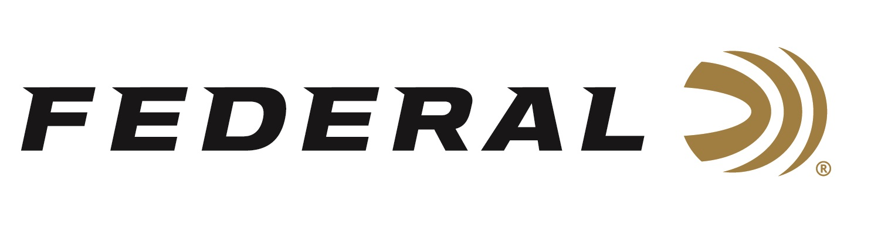

FOR IMMEDIATE RELEASE

NRA American Hunter Magazine Names Federal Premium FireStick
as a 2021 Golden Bullseye Award Winner

ANOKA, Minnesota – December 16, 2020 – The National Rifle Association’s (NRA) American Hunter magazine selected Traditions NitroFire and Federal Premium FireStick to receive its Golden Bullseye Award for 2021 Muzzleloader of the Year. Federal will be recognized in association with the award during a special reception at the 2021 NRA Annual Meetings & Exhibits on September 3-5, 2021 in Houston, Texas.

“Our new Federal Premium FireStick is a proprietary and newly-patented muzzleloading propellant system that is safer, more consistent and easier to use than ever before. Developed with Traditions and Hodgdon, the FireStick revolutionizes the inline muzzleloader platform,” said Federal’s President Jason Vanderbrink. “We are extremely proud and grateful for the staff at NRA American Hunter magazine to have recognized this innovation for its superior features and benefits.”

The NRA Publications Golden Bullseye Awards acknowledge the finest products available in the shooting sports. To qualify for consideration for a Golden Bullseye Award, the product must meet a variety of demanding criteria on design, function, value and overall contribution to the shooting industry.

“The primary benefit of the FireStick is best-in-class safety, followed by convenience, consistent accuracy, ease of cleaning, simplicity of use, and more,” said Federal Muzzleloader Product Director Rick Stoeckel. “All of which, we feel, helped this new product earn the top honor from NRA American Hunter, and we thank them for this prestigious acknowledgement.”

The FireStick is a premeasured self-contained powder charge. It consists of a polymer capsule precisely filled—using strict specifications at Federal’s ammunition plant—with an exact charge of all-new, ultra-clean black powder substitute Hodgdon Triple 8 granular powder. The sealed capsule utilizes a breakable front section (cap) that completely encases the powder charge. Currently, the FireStick is only compatible with the new NitroFire product line of muzzleloading rifles from Traditions.

Federal ammunition can be found at dealers nationwide or purchased online direct from Federal. For more information on all products from Federal or to shop online, visit www.federalpremium.com.
Press Release Contact: JJ Reich
Senior Manager – Press Relations
E-mail: VistaPressroom@VistaOutdoor.com

About Federal Ammunition
Federal, headquartered in Anoka, MN, is a brand of Vista Outdoor Inc., an outdoor sports and recreation company. From humble beginnings nestled among the lakes and woods of Minnesota, Federal Ammunition has evolved into one of the world's largest producers of sporting ammunition. Beginning in 1922, founding president, Charles L. Horn, paved the way for our success. Today, Federal carries on Horn's vision for quality products and service with the next generation of outdoorsmen and women. We maintain our position as experts in the science of ammunition production. Every day we manufacture products to enhance our customers' shooting experience while partnering with the conservation organizations that protect and support our outdoor heritage. We offer thousands of options in our Federal Premium and Federal® lines-it's what makes us the most complete ammunition company in the business and provides our customers with a choice no matter their pursuit.

