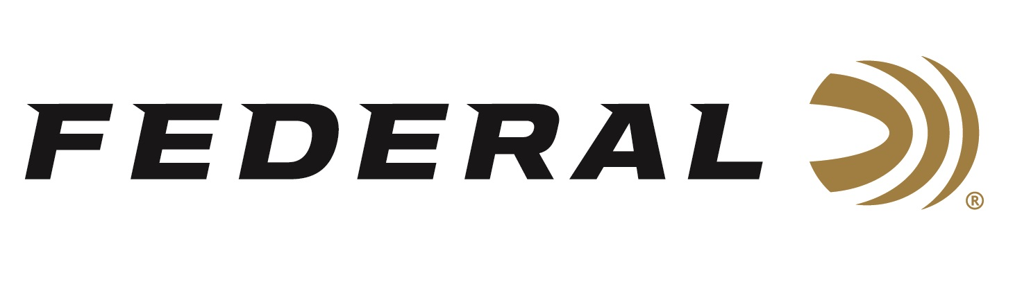

FOR IMMEDIATE RELEASE

Team Federal Hosted Successful PRS Series Gold Medal Match

ANOKA, Minnesota – September 18, 2020 – Federal Ammunition and Team Federal recently hosted its second annual Federal Gold Medal Match, a Precision Rifle Series Pro Series match, September 12-13, at Alabama Precision in Carbon Hill, Alabama.

Match Director, Jim Saunders, and his team presented a challenging course of fire for the PRS Pro Series Qualifier match which saw nearly 150 competitors battling heat, humidity and switching winds over the two days. Team Federal shooters Brian Allen and Shannon Kay both turned in strong performances with Kay finishing sixth overall and Allen finishing twelfth and earning the Top Senior trophy.

“This was a fantastic match. From the challenging course of fire to the support Federal showed the competitors, everything was top notch,” said Allan. “I’m proud to represent Team Federal and appreciate all their support for the precision rifle community.”

Greg Holloway, Ryan Hansen, Spence Pepper, Robert Brantley and Justin Pender all earned custom trophies for the top five shooters in the Open division. In addition to bringing home the coolest trophy on the entire PRS Pro Series circuit, Holloway also won a custom rifle built and presented by Team Federal’s own Brian Allen with A-Team Precision.

In other divisions, Ben Gossett earned the Top Military/Law Enforcement trophy for the second consecutive year. Phil Cashin of Masterpiece Arms won the trophy for the Production division. A strong performance from Melissa Gilliland earned her the Top Lady trophy. The Top Junior trophy went to Luke Holbrook. Finally, Mark Cooper used his .308 Win. to claim the Top Tactical trophy.

One highlight of the match came when Federal’s Shooting Sports Promotions Manager Jason Spradling and Phil Cashin from Masterpiece Arms presented a custom rifle to a deserving new shooter. The recipient, shooting his first match, was using a borrowed rifle and gear. He shot with a great attitude and showed excitement and passion for the sport.

“We at Federal recognize the importance of growing the competitive shooting sports and encouraging new shooters to be active participants,” said Spradling. “It was great to be able to present a gorgeous new MPA production rifle to a deserving new shooter.”

Federal Ammunition is the Official Ammunition of the PRS and an Affiliate Sponsor of the 2020 Precision Rifle Series Season. In May of 2021, Federal will be title sponsoring a PRS Pro Series and AG Cup Qualifier match in New Mexico. In addition, Federal will again be the title sponsor of the third annual Federal Gold Medal Match to be held at Alabama Precision in September 2021. Learn more at www.precisionrifleseries.com.

Long range isn’t just a distance. It’s a state of mind. A dedication to push further. And it’s why Federal Premium builds Gold Medal rifle loads. The exclusive primer design provides the best sensitivity and most consistent ballistics in the industry. The best-in-class, precision-built bullets loaded in this line of ammunition wins more matches than any other. Federal’s Gold Medal is the only choice for the world’s most elite shooters.

Federal ammunition can be found at dealers nationwide or purchased online direct from Federal. For more information on all products from Federal or to shop online, visit www.federalpremium.com.

Press Release Contact: JJ Reich
Senior Manager – Press Relations
E-mail: VistaPressroom@VistaOutdoor.com

About Federal Ammunition
Federal, headquartered in Anoka, MN, is a brand of Vista Outdoor Inc., an outdoor sports and recreation company. From humble beginnings nestled among the lakes and woods of Minnesota, Federal Ammunition has evolved into one of the world's largest producers of sporting ammunition. Beginning in 1922, founding president, Charles L. Horn, paved the way for our success. Today, Federal carries on Horn's vision for quality products and service with the next generation of outdoorsmen and women. We maintain our position as experts in the science of ammunition production. Every day we manufacture products to enhance our customers' shooting experience while partnering with the conservation organizations that protect and support our outdoor heritage. We offer thousands of options in our Federal Premium and Federal® lines-it's what makes us the most complete ammunition company in the business and provides our customers with a choice no matter their pursuit.

