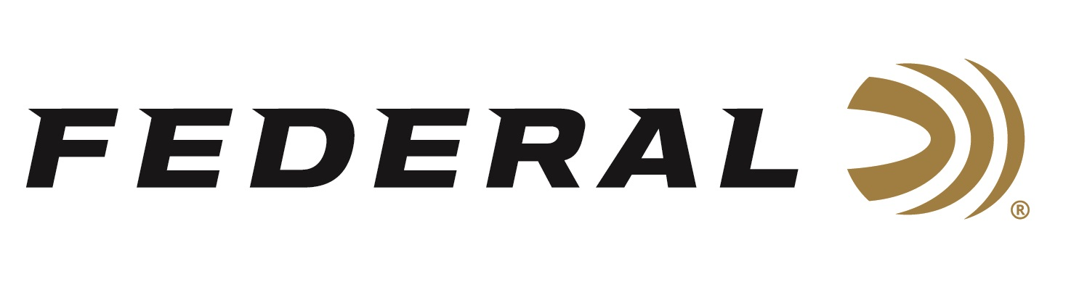

FOR IMMEDIATE RELEASE

Outdoor Life Editor-in-Chief joins “It’s Federal Season” Podcast

ANOKA, Minnesota – February 20, 2020 – Turning a passion into a career path is the topic of the latest installment of Federal Ammunition’s podcast “It’s Federal Season.” Outdoor Life’s Editor-in-Chief joins Federal’s Jason Vanderbrink and Jason Nash for a look at becoming an outdoor writer and the evolving landscape of the outdoor media. The third episode will be live for downloading on February 20, 2020.

“The way all media is consumed is rapidly changing,” says Sr. Director of Marketing Jason Nash. “Getting perspective on the way publications build and maintain their brands and platforms is very topical and we are fortunate to have one of he industry leaders on to discuss the transformation,” says Nash. In the Tech Talk segment, Director of Product Development Jared Kutney will highlight our new lever action line of ammunition called HammerDown.

Before signing off, find out what promotions are available for consumers and where consumers can meet with our ammunition team in person to talk all things ammunition. Look for more information at www.federalpremium.com or where you find your favorite podcasts.

Press Release Contact: JJ Reich
Senior Manager – Press Relations
E-mail: VistaPressroom@VistaOutdoor.com

About Federal Ammunition
Federal, headquartered in Anoka, MN, is a brand of Vista Outdoor Inc., an outdoor sports and recreation company. From humble beginnings nestled among the lakes and woods of Minnesota, Federal Ammunition has evolved into one of the world's largest producers of sporting ammunition. Beginning in 1922, founding president, Charles L. Horn, paved the way for our success. Today, Federal carries on Horn's vision for quality products and service with the next generation of outdoorsmen and women. We maintain our position as experts in the science of ammunition production. Every day we manufacture products to enhance our customers' shooting experience while partnering with the conservation organizations that protect and support our outdoor heritage. We offer thousands of options in our Federal Premium and Federal® lines-it's what makes us the most complete ammunition company in the business and provides our customers with a choice no matter their pursuit.

