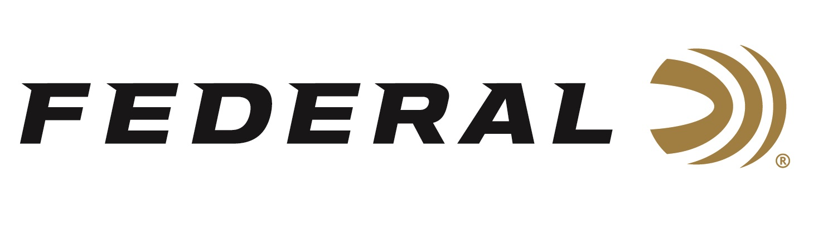

FOR IMMEDIATE RELEASE

Federal Recognized as Today’s Top Rifle Ammunition Brand

ANOKA, Minnesota – April 6, 2020 – A recent report released by Southwick Associates identifies Federal as the top rifle ammunition brand in today’s marketplace. Federal led the rifle ammo category after Southwick Associates surveyed more than 20,000 hunters and recreational shooters in 2019 through its online HunterSurvey.com and ShooterSurvey.com consumer panels.

“We’re proud to see the results of the Southwick study and that Americans are choosing Federal now more than ever,” said Vice President of Marketing Jason Nash. “Our focus has always been on those who use our products in the field and on the range. If we meet their needs, they’ll have a great experience with our brand.”

The Federal brand family of rifle ammunition, including Federal Premium, Federal, Fusion and American Eagle, were purchased by more than 33 percent of the surveyed consumers to lead all rifle brands.

“This report confirms we’ve accomplished what we’ve always worked hard to achieve,” said Federal Centerfire Rifle Product Director Mike Holm. “Our ammunition offers consistent, accurate performance for all types of recreational shooting, hunting and self-defense. Our factory workers are extremely proud of the fact that our quality ammunition continuously leads the market and delivers on the expectations of our consumers.”

More than 30 ammunition brands were examined in the Southwick Associates 2019 Hunting & Shooting Participation and Equipment Purchases Report. Southwick’s in-depth resources illustrate shopping behaviors, such as where consumers buy, brand preferences, and amount spent. Learn more at www.southwickassociates.com.

Federal’s latest ammunition introductions for 2020 are sure to impress their loyal customer base. New product highlights include:

Terminal Ascent - Bonded construction penetrates deep, while the patented Slipstream polymer tip initiates expansion even at lower velocities and long range. AccuChannel groove technology improves accuracy and minimizes drag. Available in eleven of the most popular hunting cartridges and as component bullets.

Swift Scirocco II - High ballistic coefficients produce flat trajectories, while retaining more velocity and energy downrange. Available in nine loads from 243 Win. to 300 Win. Magnum.

Federal ammunition can be found at dealers nationwide or purchased online direct from Federal. For more information on all products from Federal or to shop online, visit www.federalpremium.com.

Press Release Contact: JJ Reich
Senior Manager – Press Relations
E-mail: VistaPressroom@VistaOutdoor.com

About Federal Ammunition
Federal, headquartered in Anoka, MN, is a brand of Vista Outdoor Inc., an outdoor sports and recreation company. From humble beginnings nestled among the lakes and woods of Minnesota, Federal Ammunition has evolved into one of the world's largest producers of sporting ammunition. Beginning in 1922, founding president, Charles L. Horn, paved the way for our success. Today, Federal carries on Horn's vision for quality products and service with the next generation of outdoorsmen and women. We maintain our position as experts in the science of ammunition production. Every day we manufacture products to enhance our customers' shooting experience while partnering with the conservation organizations that protect and support our outdoor heritage. We offer thousands of options in our Federal Premium and Federal® lines-it's what makes us the most complete ammunition company in the business and provides our customers with a choice no matter their pursuit.

