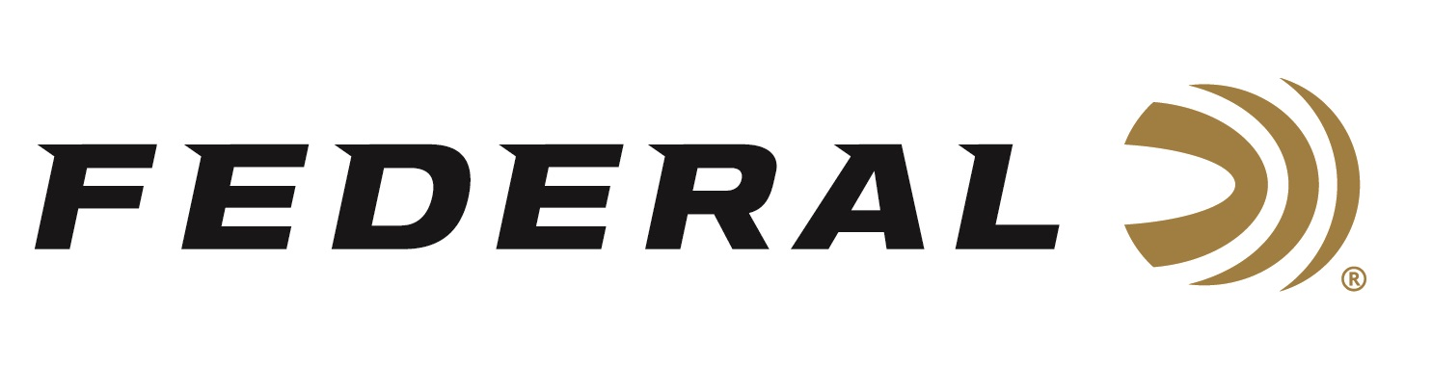

FOR IMMEDIATE RELEASE

Federal Premium Ammunition Continues Its Longtime Support of Pheasants Forever & Quail Forever

ANOKA, Minnesota – April 2, 2020 – Federal Premium is proud to announce its continued support of Pheasants Forever & Quail Forever, the nation’s leading upland habitat conservation organization. Federal reports it has also recently surpassed a total of 55 million shotgun shells sold under its Pheasants Forever royalty program benefiting the organization’s habitat mission. These special shells are all sold in boxes marked with the organization’s logo. And in time for the 2020 upland bird hunting season, the collaboration will bring a new Quail Forever load to market.

“Federal has been a corporate leader and great friend to Pheasants Forever and Quail Forever for more than three decades,” explained Howard K. Vincent, Pheasants Forever & Quail Forever’s President and CEO. “Since the mid-1980s, Federal has walked beside our organization as true partners in conservation. From the ground-breaking on-the-box royalty program to the Build a Wildlife Area campaign to create public land for hunters, and all the way to shared advocacy efforts for CRP during Federal Farm Bills efforts. We greatly appreciate their support.”

Federal Ammunition was presented a Corporate Partners in Conservation Longtail Award at the 2020 National Pheasant Fest & Quail Classic in Minneapolis, Minnesota this past February. Federal President Jason Vanderbrink accepted the award.

“We are proud of all the accomplishments we have achieved throughout the years with this outstanding conservation organization. Especially efforts to recruit, retain, and reactivate a new generation of bird hunters by supporting learn-to-hunt events, youth shooting sports programs, and youth mentor hunts,” said Vanderbrink. “The relationship also helped lead to our development of the Prairie Storm ammunition name, logo, and packaging which ultimately helps our customers be more successful in the field. We sincerely thank Pheasants Forever and Quail Forever for all they do for conservationists and upland hunting enthusiasts nationwide.”

Federal Premium and Pheasants Forever’s on-box royalty program began in 1998 with Federal Premium’s Pheasants Forever-labeled Wing-Shok shotgun shell boxes. The program evolved in 2010 with the revolutionary Prairie Storm specialty pheasant load, and it continued to grow in 2011 with the introduction of Prairie Storm FS Steel. For 2020, Federal has exciting new products ready to join the royalty program; including, four new 16- and 28-gauge loads featuring the updated FLITECONTROL FLEX wad and a mixed payload of standard pellets and FLITESTOPPER lead to produce full, consistent patterns. The partners are also thrilled to introduce Quail Forever logoed Federal loads as well. A portion of the proceeds from each Pheasants Forever & Quail Forever logoed box sold goes directly to the conservation group’s wildlife habitat efforts, contributing to sustainable pheasant and quail populations, and increased upland hunter participation.

Pheasants Forever, including its quail conservation division, Quail Forever, is the nation's largest nonprofit organization dedicated to upland habitat conservation. For more information, go to www.pheasantsforever.org.

Federal ammunition can be found at dealers nationwide or purchased online direct from Federal. For more information on all products from Federal or to shop online, visit www.federalpremium.com.

Press Release Contact: JJ Reich
Senior Manager – Press Relations
E-mail: VistaPressroom@VistaOutdoor.com

About Federal Ammunition
Federal, headquartered in Anoka, MN, is a brand of Vista Outdoor Inc., an outdoor sports and recreation company. From humble beginnings nestled among the lakes and woods of Minnesota, Federal Ammunition has evolved into one of the world's largest producers of sporting ammunition. Beginning in 1922, founding president, Charles L. Horn, paved the way for our success. Today, Federal carries on Horn's vision for quality products and service with the next generation of outdoorsmen and women. We maintain our position as experts in the science of ammunition production. Every day we manufacture products to enhance our customers' shooting experience while partnering with the conservation organizations that protect and support our outdoor heritage. We offer thousands of options in our Federal Premium and Federal lines-it's what makes us the most complete ammunition company in the business and provides our customers with a choice no matter their pursuit.

