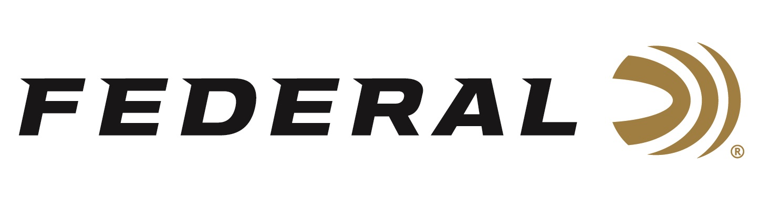

FOR IMMEDIATE RELEASE

Federal Introduces FireStick: New Ground-Breaking Muzzleloader Rifle Propellant System

ANOKA, Minnesota – January 21, 2020 – The expert engineers at Federal Ammunition knew there could be a better, easier and safer way to hunt with a muzzleloader. New for 2020, Federal Ammunition is launching FireStick, a proprietary and newly-patented muzzleloading propellant system that is safer and easier to use than ever before. Developed with Traditions and Hodgdon, this new system revolutionizes a platform for hunting enthusiasts.

This new product will be on display in Booth No. 14551 at the 2020 SHOT Show, January 21-24 at the Sands Expo Center in Las Vegas, Nevada. The FireStick is scheduled to ship in the Summer of 2020.

The new Federal Premium FireStick is a premeasured self-contained powder charge. It consists of a polymer capsule precisely filled—using strict specifications at Federal’s ammunition plant—with an exact charge of all-new, ultra-clean black powder substitute Hodgdon Triple 8 granular powder. The sealed capsule utilizes a breakable front section (cap) that completely encases the powder charge. To see more, visit https://www.federalpremium.com/firestick.html.

The primary benefit of the FireStick is best-in-class safety, followed by convenience, consistent accuracy, ease of cleaning, simplicity of use, and more. See a promotional product video here: https://www.youtube.com/watch?v=KGqSxUFakQk

Operation of the FireStick system is simple. First, the bullet is loaded from the muzzle to seat on top of a bullet shelf inside the barrel of the rifle. The break-open action of the rifle is opened. The FireStick is then installed into the open breech to seat just behind the bullet shelf and seated bullet. A 209 Muzzleloader primer is inserted into the FireStick propellant capsule to charge the powder. The break-open action is closed. It’s now ready to fire, once the hammer is pulled back and the safety is turned off.

Upon product launch, Traditions has an exclusive arrangement utilizing the FireStick system. At the time of print, one NitroFire .50 caliber rifle is available from Traditions. In addition, the company plans on launching several different rifles at various feature levels and price points to accommodate a wide range of customer preferences. Please visit www.Traditionsfirearms.com for more information.

The FireStick is sold in 10-count packs and carries an MSRP of $26.95 per pack. At launch, two pre-loaded FireStick charge levels will be available: 100-grains or 120-grains Hodgdon Triple 8. Users can expect projectile velocities equal to or better than what they are getting with equivalent loads from other types of in-line muzzleloaders. Learn more about Hodgdon’s new Triple 8 muzzleloader powder by visiting www.Hodgdon.com.

Research conducted by Federal Ammunition shows that many states define a muzzleloader by the requirement of loading the projectile down the muzzle manually. By this definition, many states should allow the FireStick to be legal for hunting big game during their muzzleloader seasons. However, all hunters should check their state regulations to ensure legality before use.

Federal ammunition can be found at dealers nationwide or purchased online direct from Federal. For more information on all products from Federal or to shop online, visit www.federalpremium.com.

Press Release Contact: JJ Reich
Senior Manager – Press Relations
E-mail: VistaPressroom@VistaOutdoor.com

About Federal Ammunition
Federal, headquartered in Anoka, MN, is a brand of Vista Outdoor Inc., an outdoor sports and recreation company. From humble beginnings nestled among the lakes and woods of Minnesota, Federal Ammunition has evolved into one of the world's largest producers of sporting ammunition. Beginning in 1922, founding president, Charles L. Horn, paved the way for our success. Today, Federal carries on Horn's vision for quality products and service with the next generation of outdoorsmen and women. We maintain our position as experts in the science of ammunition production. Every day we manufacture products to enhance our customers' shooting experience while partnering with the conservation organizations that protect and support our outdoor heritage. We offer thousands of options in our Federal Premium and Federal® lines-it's what makes us the most complete ammunition company in the business and provides our customers with a choice no matter their pursuit.

