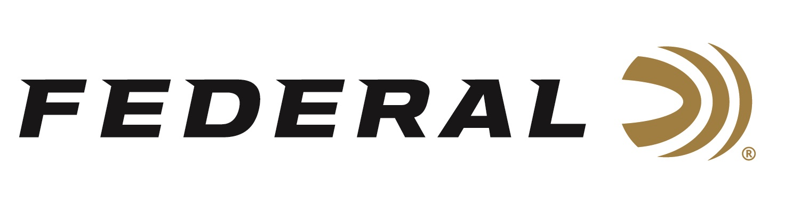

FOR IMMEDIATE RELEASE

Federal Ammunition Introduces New FireStick to Revolutionize Hunting with Muzzleloaders

ANOKA, Minnesota – September 30, 2020 – As long as there have been muzzleloading firearms, their shooters have been burdened by reliability, consistency and safety concerns. The new Federal Premium FireStick solves those issues. It is the main component of a whole new ignition system that uses an encapsulated propellant charge inserted from the breech, with the bullet loaded from the muzzle. The result is a safer, cleaner, more convenient and reliable way to hunt with a muzzleloader. Shipments of this new product have begun to arrive at dealers.

The FireStick charge is completely impervious to moisture. It features clean-burning Hodgdon Triple Eight powder and is loaded to the same tight tolerances as other Federal Premium factory ammunition. This ensures shot-to-shot consistency and accuracy that muzzleloaders have never experienced before. FireStick can be removed quickly, simply and safely by slipping it out of the action—there’s no need to fire the rifle to unload it.

“The primary benefit of the FireStick is best-in-class safety. Its design allows for a hunter to quickly and easily uninstall it whenever needed, such as to cross a fence, climb into a treestand, enter a blind, or ride in a vehicle,” said Federal Muzzleloader Product Manager Dan Compton. “It also delivers a safer shooting experience because using factory-controlled, precision-measured, pre-filled powder charges eliminates the risk of accidentally over-charging a rifle to dangerous levels.”

Features & Benefits
- Polymer charge filled with clean-burning Hodgdon Triple Eight powder
- Charges from the breech of Traditions NitroFire rifle
- Bullet loads from the muzzle
- Totally impervious to moisture and the elements
- Same tight tolerances and quality controls as loaded ammunition
- Fast, effortless loading and unloading
- Shooter inserts 209 shotgun primer (not included)

The FireStick can be used with the shooter’s choice of bullets and primers. It is the perfect match for Federal Premium Trophy Copper or Lead Tipped muzzleloader bullets and 209 Muzzleloading Primers. Currently, the FireStick is only compatible with the new NitroFire rifle from Traditions. Initially, FireStick will be available from dealers of Federal Ammunition and Traditions Firearms. Learn more at: https://www.federalpremium.com/firestick.html.

Part No. / Description / MSRP
PMZFS100T8 / 100-grain FireStick / $26.99
https://www.federalpremium.com/muzzleloading/firestick/11-PMZFS100T8.html
PMZFS120T9 / 120-grain FireStick / $26.99
https://www.federalpremium.com/muzzleloading/firestick/11-PMZFS120T8.html

Federal ammunition can be found at dealers nationwide or purchased online direct from Federal. For more information on all products from Federal or to shop online, visit www.federalpremium.com.

Press Release Contact: JJ Reich
Senior Manager – Press Relations
E-mail: VistaPressroom@VistaOutdoor.com

About Federal Ammunition
Federal, headquartered in Anoka, MN, is a brand of Vista Outdoor Inc., an outdoor sports and recreation company. From humble beginnings nestled among the lakes and woods of Minnesota, Federal Ammunition has evolved into one of the world's largest producers of sporting ammunition. Beginning in 1922, founding president, Charles L. Horn, paved the way for our success. Today, Federal carries on Horn's vision for quality products and service with the next generation of outdoorsmen and women. We maintain our position as experts in the science of ammunition production. Every day we manufacture products to enhance our customers' shooting experience while partnering with the conservation organizations that protect and support our outdoor heritage. We offer thousands of options in our Federal Premium and Federal® lines-it's what makes us the most complete ammunition company in the business and provides our customers with a choice no matter their pursuit.

