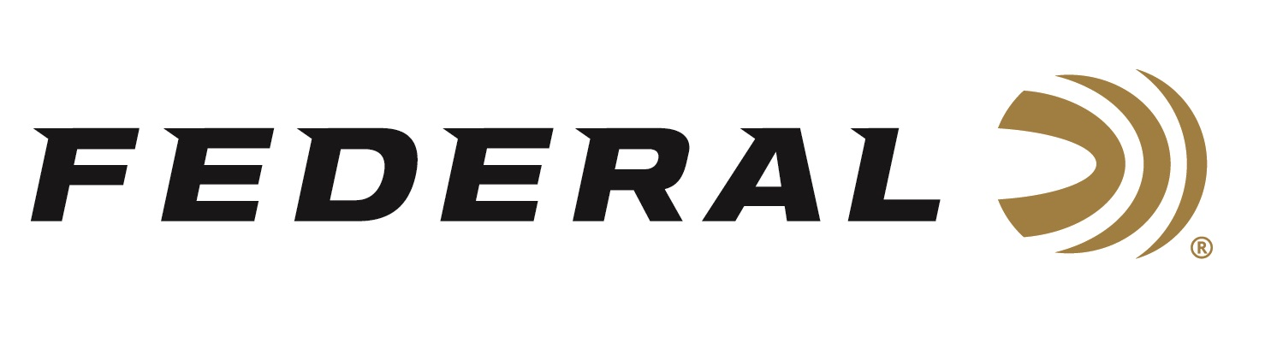

FOR IMMEDIATE RELEASE

Field & Stream Magazine Honors Federal Premium FireStick as Best of the Best for 2020

ANOKA, Minnesota – November 5, 2020 – Field & Stream magazine has recognized the Tradition’s NitroFire muzzleloading rifle and the Federal Premium Firestick with a Best-of-the-Best Award. New for 2020, FireStick is a proprietary and newly-patented muzzleloading propellant system that is safer and easier to use than ever before. Developed with Traditions and Hodgdon, this new system revolutionizes a muzzleloader platform for hunting enthusiasts.

"You’ve never seen a muzzleloader quite like this one,” said Field & Stream Hunting Editor Will Brantley. “The gun I've been shooting couldn't be easier to load or clean, and it turned in groups of just under 2 inches at 100 yards with Federal B.O.R. Lock MZ copper bullets and 100-grain charges. If we had an innovation award, the NitroFire and Firestick would get it."

The new Federal Premium FireStick is a premeasured self-contained powder charge. It consists of a polymer capsule precisely filled—using strict specifications at Federal’s ammunition plant—with an exact charge of all-new, ultra-clean black powder substitute Hodgdon Triple 8 granular powder. The sealed capsule utilizes a breakable front section (cap) that completely encases the powder charge.

“The primary benefit of the FireStick is best-in-class safety, followed by convenience, consistent accuracy, ease of cleaning, simplicity of use, and more,” said Federal Muzzleloader Product Director Rick Stoeckel. “All of which, we feel, helped this new product earn the top honor from Field & Stream, and we thank them for this prestigious acknowledgement.”

The FireStick is sold in 10-count packs of 100-grains or 120-grains equivalent of Hodgdon Triple 8 and carries an MSRP of $27.99 per pack. Currently, the FireStick is only compatible with the new NitroFire rifle from Traditions.

Federal ammunition can be found at dealers nationwide or purchased online direct from Federal. For more information on all products from Federal or to shop online, visit www.federalpremium.com. For more information on the Traditions NitroFire, visit www.traditionsfirearms.com.

Press Release Contact: JJ Reich
Senior Manager – Press Relations
E-mail: VistaPressroom@VistaOutdoor.com

About Federal Ammunition
Federal, headquartered in Anoka, MN, is a brand of Vista Outdoor Inc., an outdoor sports and recreation company. From humble beginnings nestled among the lakes and woods of Minnesota, Federal Ammunition has evolved into one of the world's largest producers of sporting ammunition. Beginning in 1922, founding president, Charles L. Horn, paved the way for our success. Today, Federal carries on Horn's vision for quality products and service with the next generation of outdoorsmen and women. We maintain our position as experts in the science of ammunition production. Every day we manufacture products to enhance our customers' shooting experience while partnering with the conservation organizations that protect and support our outdoor heritage. We offer thousands of options in our Federal Premium and Federal® lines-it's what makes us the most complete ammunition company in the business and provides our customers with a choice no matter their pursuit.

