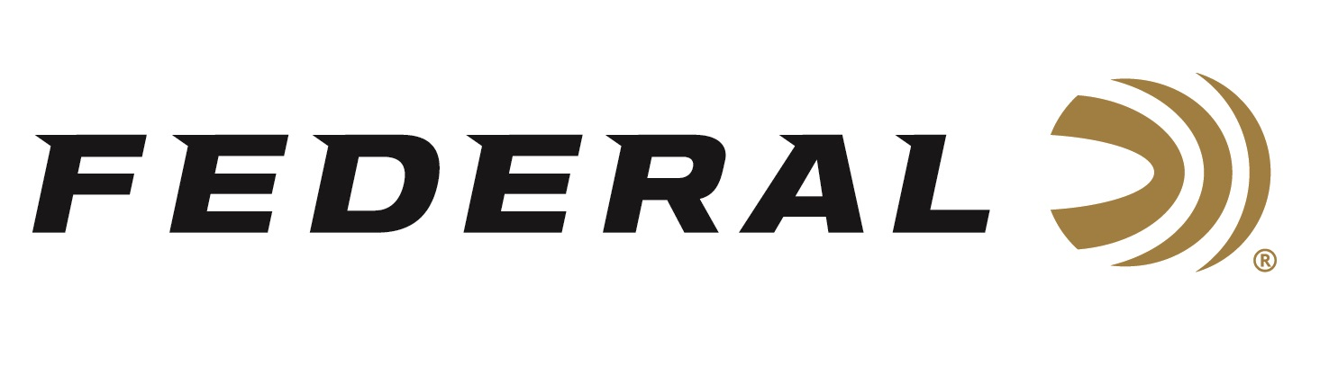

FOR IMMEDIATE RELEASE

Federal’s New FireStick Awarded Innovation of the Year
by Guns & Ammo Magazine

ANOKA, Minnesota – November 3, 2020 – Guns & Ammo magazine has given the Federal Premium Firestick its Innovation of the Year award due to its potential to revolutionize the world's oldest long gun: the muzzleloader. Federal’s FireStick is a proprietary and newly-patented muzzleloading propellant system that is safer and easier to use than ever before. Developed with Traditions and Hodgdon, this new system revolutionizes a muzzleloader platform for hunting enthusiasts.

“From the improved ease and safety of loading, inspection and unloading, the FireStick addresses nearly every issue with modern muzzleloading,” said Guns & Ammo Editor Eric Poole. “Not since the 1985-introduction of the in-line muzzleloader has there been as impactful of a development. And it should not be overlooked that by sealing a consistent powder charge, Federal has managed to improve a muzzleloader’s accuracy potential and consistency downrange.”

“As long as there have been muzzleloading firearms, their shooters have been burdened by reliability, consistency and safety concerns. The new Federal Premium FireStick solves those issues,” said Federal Muzzleloader Product Director Rick Stoeckel. “Our encapsulated propellant charge is a safer, cleaner, more convenient and reliable way to hunt with a muzzleloader. We truly appreciate this highly regarded recognition of the innovation our team worked so hard to achieve.”

The FireStick charge is completely impervious to moisture. It features clean-burning Hodgdon Triple Eight powder and is loaded to the same tight tolerances as other Federal Premium factory ammunition. This ensures shot-to-shot consistency and accuracy that muzzleloaders have never experienced before. FireStick can be removed quickly, simply and safely by slipping it out of the action—there’s no need to fire the rifle to unload it.

The FireStick can be used with the shooter’s choice of bullets and primers. It is the perfect match for Federal Premium Trophy Copper or Lead Tipped muzzleloader bullets and 209 Muzzleloading Primers. Currently, the FireStick is only compatible with the new NitroFire rifle from Traditions. Learn more at: https://www.federalpremium.com/firestick.html.

Federal ammunition can be found at dealers nationwide or purchased online direct from Federal. For more information on all products from Federal or to shop online, visit www.federalpremium.com.

Press Release Contact: JJ Reich
Senior Manager – Press Relations
E-mail: VistaPressroom@VistaOutdoor.com

About Federal Ammunition
Federal, headquartered in Anoka, MN, is a brand of Vista Outdoor Inc., an outdoor sports and recreation company. From humble beginnings nestled among the lakes and woods of Minnesota, Federal Ammunition has evolved into one of the world's largest producers of sporting ammunition. Beginning in 1922, founding president, Charles L. Horn, paved the way for our success. Today, Federal carries on Horn's vision for quality products and service with the next generation of outdoorsmen and women. We maintain our position as experts in the science of ammunition production. Every day we manufacture products to enhance our customers' shooting experience while partnering with the conservation organizations that protect and support our outdoor heritage. We offer thousands of options in our Federal Premium and Federal® lines-it's what makes us the most complete ammunition company in the business and provides our customers with a choice no matter their pursuit.

