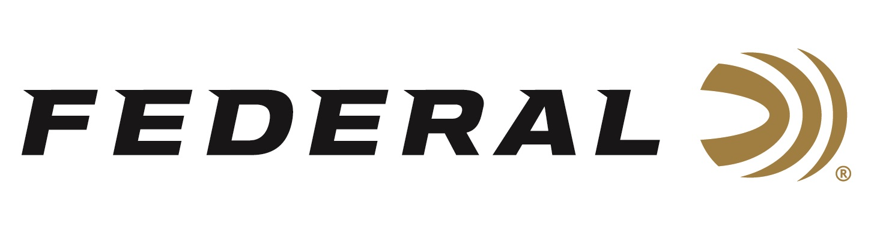

FOR IMMEDIATE RELEASE

Federal Ammunition Now Offers 350 Legend in Its Fusion Line

ANOKA, Minnesota – June 15, 2020 – The 350 Legend cartridge offers higher velocities than any straight-wall, deer-hunting cartridge. Federal initially launched the 350 Legend cartridge into its product catalog by offering two soft-point 180-grain options in its Power-Shok and Non-Typical lines. Now, Federal upgrades its product mix by adding a molecularly-bonded Fusion load in the lighter weight of 160 grains. Shipments of this product have begun to arrive at dealers.

“The 350 Legend delivers superior ballistics and fast velocities for a straight-wall cartridge. It has become quite popular because it’s legal for hunting in many areas where bottleneck centerfire rifle cartridges are prohibited,” said Federal Centerfire Product Manager Eric Miller. “Fusion is one of our most loved product lines because it offers best-in-class performance. Offering 350 Legend in our trusted Fusion lineup is something we know deer hunters will appreciate.”

The 350 Legend cartridge touts significantly less recoil than 450 Bushmaster and more energy than 223 Rem. It’s an ideal fit for compact, maneuverable MSRs and bolt-action rifles. It also delivers ample energy to take down any buck.

Fusion provides the largest expansion and highest weight retention in its class, making it the ideal choice for this modern straight-wall cartridge. With a molecularly-fused jacket and a pressure-formed core, Fusion transfers maximum energy on target with reliable, tag-filling accuracy.

Features
- New 350 Legend 160-grain option
- Copper jacket is electro-chemically applied to its pressure-formed lead core
- Skived, pre-programmed nose provides consistent expansion
- Maximum weight retention for deep penetration
- Quality components and excellent accuracy

https://www.federalpremium.com/rifle/fusion/fusion-rifle/11-F350LFS1.html

Part No. / Description / MSRP
F350LFS1 / Fusion 350 Legend 160-grain, 20-count / $32.95

Federal ammunition can be found at dealers nationwide or purchased online direct from Federal. For more information on all products from Federal or to shop online, visit www.federalpremium.com.

Press Release Contact: JJ Reich
Senior Manager – Press Relations
E-mail: VistaPressroom@VistaOutdoor.com

About Federal Ammunition
Federal, headquartered in Anoka, MN, is a brand of Vista Outdoor Inc., an outdoor sports and recreation company. From humble beginnings nestled among the lakes and woods of Minnesota, Federal Ammunition has evolved into one of the world's largest producers of sporting ammunition. Beginning in 1922, founding president, Charles L. Horn, paved the way for our success. Today, Federal carries on Horn's vision for quality products and service with the next generation of outdoorsmen and women. We maintain our position as experts in the science of ammunition production. Every day we manufacture products to enhance our customers' shooting experience while partnering with the conservation organizations that protect and support our outdoor heritage. We offer thousands of options in our Federal Premium and Federal® lines-it's what makes us the most complete ammunition company in the business and provides our customers with a choice no matter their pursuit.

