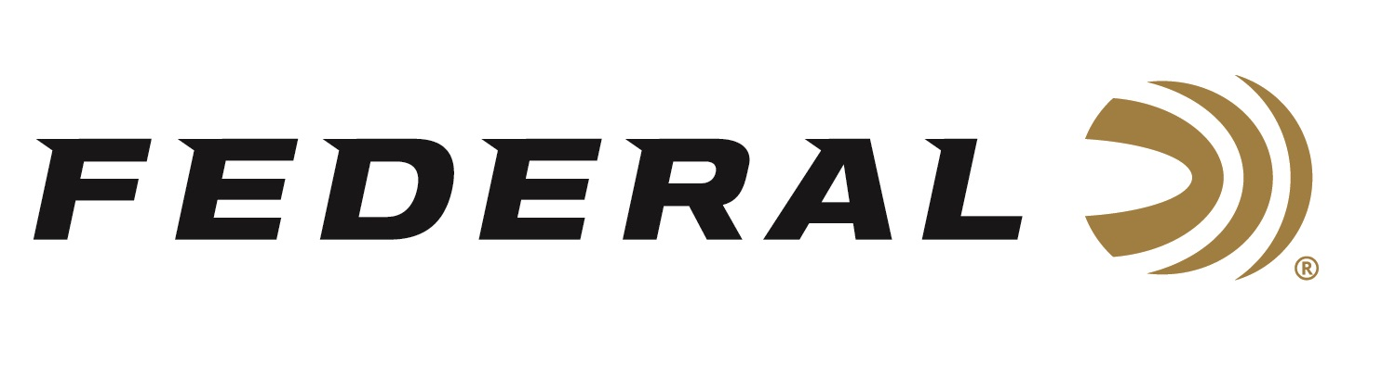

FOR IMMEDIATE RELEASE

Competition Season Off to a Strong Start for Federal and CCI Sponsored Shooter Grant Kunkel

ANOKA, Minnesota – June 25, 2020 – Federal and CCI Ammunition sponsored shooter Grant Kunkel used products from these trusted brands to win big in both Rimfire and Pistol Caliber Carbine at two recent championship events.

“Grant is in his second year as a member of our team. He was recommended to us by one of our customers and apparently bought his first 22 LR firearm only 2 1/2 years ago. He’s made tremendous progress, as evidenced by his time of only 58.5 seconds in the Rimfire Rifle Iron Sights category. A time like has the potential to be a world record,” said Federal Shooting Sports Promotions Manager Jason Spradling. “Grant is pretty soft-spoken, but he’s a great kid and a heck of an ambassador for Federal. We congratulate him on his recent successes.”

Kunkel took home High Overall honors, besting 361 fellow competitors at the 2020 Area 5 Steel Challenge Championship in Riley, Indiana. In that match, he had five total first place finishes which also included the categories of Rimfire Rifle Open, Pistol Caliber Carbine Open and Carry Optics. Kunkel shoots CCI Mini-Mag during rimfire competitions. Mini-Mag was CCI’s original offering decades ago, and it's still one of the brand’s most popular. The accurate 22 LR load feeds reliably and minimizes fouling thanks to clean-burning powder, and it feeds reliably thanks to CCI priming and brass.

Kunkel also shot well at the recent 2020 USPSA Multigun Nationals Match in Frostproof, Florida. He placed 14th Overall out of 340 competitors and 3rd in the Master class. He ran Federal Premium Syntech PCC 130-grain during that match. Syntech PCC is built to meet the exhaustive demands of fast-pace Pistol Caliber Carbine competitions, with flawless function in carbine platforms. Velocity and accuracy are optimized for long gun barrel lengths, with a bullet profile that provides excellent accuracy and reliable feeding. Syntech PCC uses a polymer jacket to eliminate metal fouling and drastically reduce heat and friction.

“I use CCI Mini-Mag through all of my rimfire guns, it gives me the confidence to shoot my best,” reported Kunkel. “For handguns, shooting Federal Premium Syntech PCC 130-grain really helps, especially with longer-range targets. It’s extremely soft recoil, accuracy, and faster bullet helped me make quick shots while staying on target.”

Federal and CCI ammunition can be found at dealers nationwide or purchased online direct. For more on Federal ammunition, visit www.federalpremium.com. For more information on CCI Ammunition, go to www.cci-ammunition.com.

Press Release Contact: JJ Reich
Senior Manager – Press Relations
E-mail: VistaPressroom@VistaOutdoor.com

About Federal Ammunition
Federal, headquartered in Anoka, MN, is a brand of Vista Outdoor Inc., an outdoor sports and recreation company. From humble beginnings nestled among the lakes and woods of Minnesota, Federal Ammunition has evolved into one of the world's largest producers of sporting ammunition. Beginning in 1922, founding president, Charles L. Horn, paved the way for our success. Today, Federal carries on Horn's vision for quality products and service with the next generation of outdoorsmen and women. We maintain our position as experts in the science of ammunition production. Every day we manufacture products to enhance our customers' shooting experience while partnering with the conservation organizations that protect and support our outdoor heritage. We offer thousands of options in our Federal Premium and Federal® lines-it's what makes us the most complete ammunition company in the business and provides our customers with a choice no matter their pursuit.

