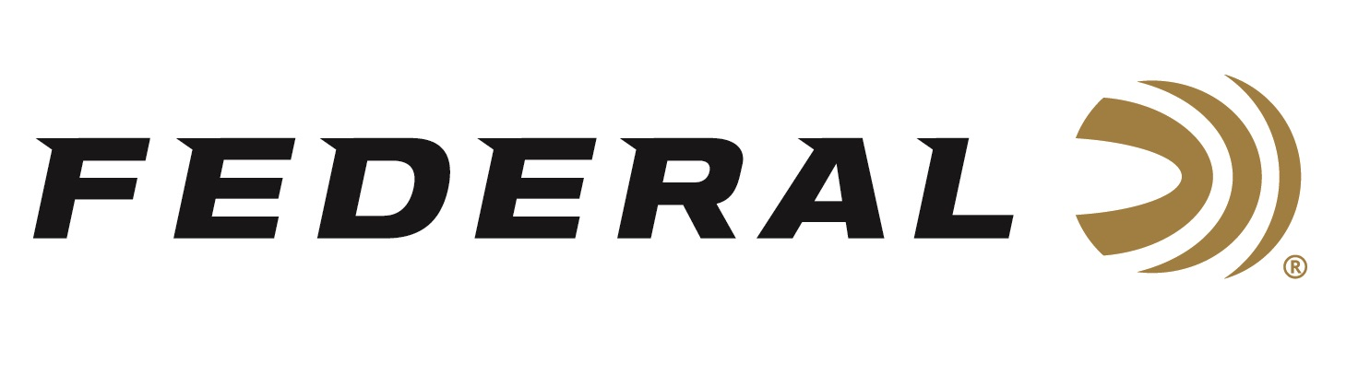

FOR IMMEDIATE RELEASE

Federal Ammunition Introduces New HammerDown: The Only
Hunting Ammo Truly Optimized for Lever-Action Rifles

ANOKA, Minnesota – October 14, 2020 – Federal Ammunition is proud to introduce the industry’s only ammunition truly designed for optimal cycling and overall performance from the time-tested, lever-action rifle platform. Shipments of this product have begun to arrive at dealers.

“Our goal for this new line of ammunition was to deliver enhanced performance in any lever-action rifle. HammerDown provides the velocity and terminal performance required to be an effective and ethical hunting round for medium game, especially with traditional handgun cartridges such as 357 Magnum or 44 Rem. Magnum being shot out of a rifle,” said Federal Ammunition Centerfire Rifle Product Manager Eric Miller. “We also ensured feeding performance in all lever-action rifles: tube feed as well as side gate firearms. To do this, we use modified case geometry to eliminate any feeding issues. HammerDown delivers those main benefits and much more.”

Velocities of all-new Federal Premium HammerDown loads are customized to produce superior ballistics and terminal performance through lever-action barrel lengths. The construction of the molecularly bonded soft point bullets has also been adjusted for the best accuracy and expansion at those velocities. The geometry of each round’s case, bullet and cartridge ensures flawless cycling through tubular magazine and typical lever-action feeding systems. Available in the most popular lever-action cartridges, including 30-30 Win., 357 Magnum, 327 Federal and 44 Rem. Magnum. Additional cartridges will be added to the lineup in 2021.

Features & Benefits
- Specifically engineered for lever guns
- Functions flawlessly in side gate loading and tubular magazines
- Modified chamfered case for easier feeding
- Bullets optimized for better terminal performance out of lever-action rifles
- Designed in partnership with Henry Repeating Arms
- Bullets provide best-in-class expansion and weight retention on impact
- Increased velocities and performance in pistol cartridges
- Nickel-plated cases for corrosion resistance

Part No. / Description / MSRP
LG3571 / 357 Magnum 170 grain, 20-count / $24.99
LG327F1 / 327 Federal 127 grain, 20-count / $30.99
LG441 / 44 Rem. Magnum 270 grain, 20-count / $28.99
LG30301 / 30-30 Win. 150 grain, 20-count / $26.99
LG45701 / 45-70 Govt. 300 grain, 20-count / $50.99

https://www.federalpremium.com/search?q=HammerDown&search-button=&lang=default

Federal ammunition can be found at dealers nationwide or purchased online direct from Federal. For more information on all products from Federal or to shop online, visit www.federalpremium.com.

Press Release Contact: JJ Reich
Senior Manager – Press Relations
E-mail: VistaPressroom@VistaOutdoor.com

About Federal Ammunition
Federal, headquartered in Anoka, MN, is a brand of Vista Outdoor Inc., an outdoor sports and recreation company. From humble beginnings nestled among the lakes and woods of Minnesota, Federal Ammunition has evolved into one of the world's largest producers of sporting ammunition. Beginning in 1922, founding president, Charles L. Horn, paved the way for our success. Today, Federal carries on Horn's vision for quality products and service with the next generation of outdoorsmen and women. We maintain our position as experts in the science of ammunition production. Every day we manufacture products to enhance our customers' shooting experience while partnering with the conservation organizations that protect and support our outdoor heritage. We offer thousands of options in our Federal Premium and Federal® lines-it's what makes us the most complete ammunition company in the business and provides our customers with a choice no matter their pursuit.

