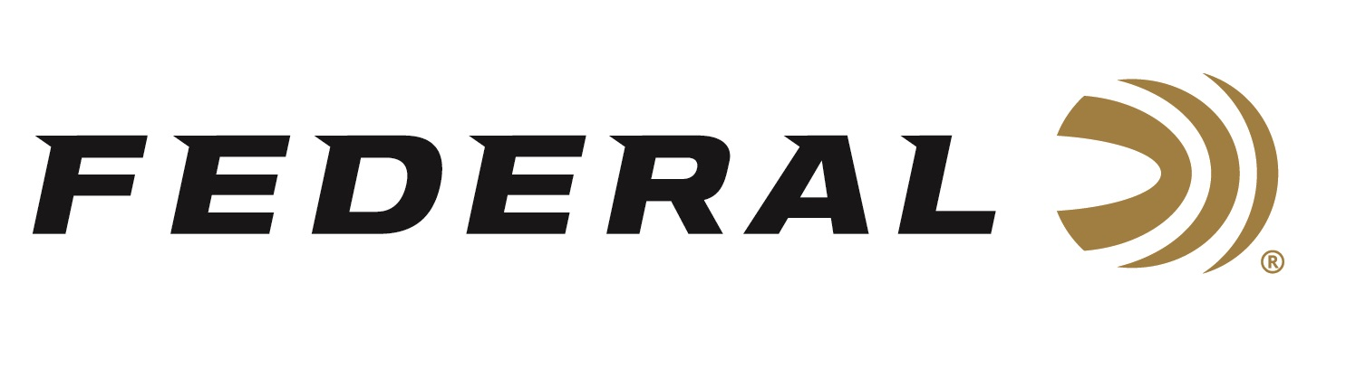

FOR IMMEDIATE RELEASE

Federal Introduces Hydra-Shok Deep in 380 Auto that Delivers
the Industry’s Best Penetration Depths

ANOKA, Minnesota – January 14, 2020 – The newest addition to Federal’s Hydra-Shok Deep lineup is the industry’s first expanding 380 Auto to consistently meet FBI protocol recommendations for penetration (12 inches minimum) through bare gel and through heavy clothing.

This new product will be on display in Booth No. 14551 at the 2020 SHOT Show, January 21-24 at the Sands Expo Center in Las Vegas, Nevada. New Federal Premium Hydra-Shok Deep 380 Auto is scheduled to ship in the Spring of 2020.

In the past three years, Federal Premium’s new Hydra-Shok Deep ammunition product line has been greatly recognized by its customers—and the industry—for its improved penetration and superior reliability. This has been most recently proven by it winning a 2019 NRA Golden Bullseye Award for “Ammo of the Year” by Shooting Illustrated magazine.

In response to the growing popularity of ultra-compact handguns by citizens of all ages, genders and demographics—particularly among shooters looking for a downsized yet effective defender— Federal Premium has expanded its award-wining Hydra-Shok Deep lineup with a new 99-grain 380 Auto load. This new offering is tailor-made for arming compact, concealed-carry “pocket pistols” or “micro guns” with an expanding, yet deepest-penetrating round. The new Hydra-Shok Deep 380 Auto even exceeds the FBI protocol performance measures of 12 inches minimum through both the bare gel and heavy clothing tests. These are achievements the industry has never seen before in the 380 Auto cartridge.

“FBI protocol incudes a series of rigorous scenarios. Bullets are shot through materials such as 10-percent ordinance gelatin, laminated automotive safety glass, plywood, wallboard and heavy clothing specified by the FBI,” said Federal Handgun Ammunition Product Manager Chris Laack. “While our larger caliber ammunition is designed to meet and exceed these requirements, the smaller 380 Auto is designed to offer the best possible blend of performance in a compact handgun platform.”

Testing done by Federal ammunition engineers in their Anoka, Minnesota facilities showed typical results of 13 to 13 ½ inches of penetration in bare gel and 13 ¼ to 14 inches through heavy clothing. Test gun barrel lengths were from common, compact handguns ranging from 2 ¾ to 3 ½ inches. The bullet and load are also fine-tuned to ensure delivery of consistent performance across all handgun platforms, including ones with longer barrels, to stay within that 13- to 14-inch goal range.

Hydra-Shok Deep has quickly become a favorite of those who rely on ammunition to protect themselves and their families. The product lineup now consists of four loads with the new 380 Auto 99-grain being the latest. Also available are 9mm Luger 135-grain, 40 S&W 165-grain and 45 Auto 210-grain. Manufacturer’s Suggested Retail Prices range from $25.95 to $33.95 from 20-count boxes.

Federal ammunition can be found at dealers nationwide or purchased online direct from Federal. For more information on all products from Federal or to shop online, visit www.federalpremium.com.

Press Release Contact: JJ Reich
Senior Communications Manager - Ammunition
E-mail: VistaPressroom@VistaOutdoor.com

About Federal Ammunition
Federal, headquartered in Anoka, MN, is a brand of Vista Outdoor Inc., an outdoor sports and recreation company. From humble beginnings nestled among the lakes and woods of Minnesota, Federal Ammunition has evolved into one of the world's largest producers of sporting ammunition. Beginning in 1922, founding president, Charles L. Horn, paved the way for our success. Today, Federal carries on Horn's vision for quality products and service with the next generation of outdoorsmen and women. We maintain our position as experts in the science of ammunition production. Every day we manufacture products to enhance our customers' shooting experience while partnering with the conservation organizations that protect and support our outdoor heritage. We offer thousands of options in our Federal Premium and Federal® lines-it's what makes us the most complete ammunition company in the business and provides our customers with a choice no matter their pursuit.

