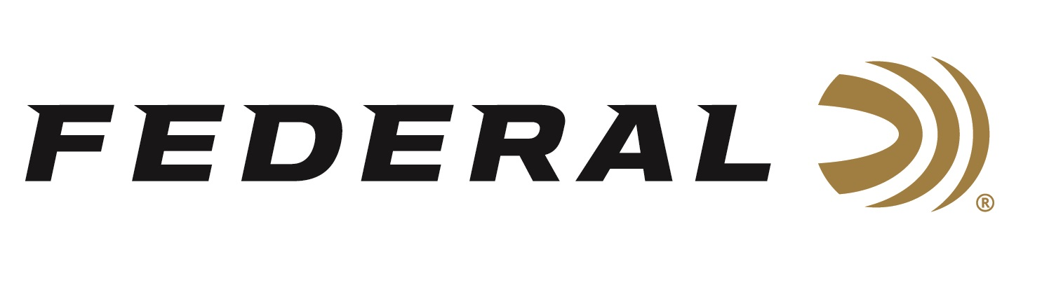

FOR IMMEDIATE RELEASE

Federal Ammunition Continues Strong Support for the International Hunter Education Association-USA

ANOKA, Minnesota – September 22, 2020 – Federal Ammunition and Vista Outdoor announced its continued support of International Hunter Education Association-USA (IHEA-USA) with a large, dedicated sponsorship aimed at developing a new IHEA-USA website. This effort will help bring the organization into the modern digital age through the rebuilding of their digital presence and website infrastructure. Vista Outdoor, Federal’s parent company, has matched Federal’s donation and will be an active supporter as this project moves forward.

“IHEA-USA has been in need of these digital improvements,” says current IHEA-USA COO Alex Baer. “This change will allow us to modernize our benefits and the delivery of our content to our current members, including enthusiasts, instructors and new hunters. Visitors looking to become more involved with hunter education will feel more welcome with an improved user experience, and IHEA-USA will have an easier time managing the site in real-time through an enhanced, more flexible platform. Education is all about reach and relevancy. Thanks to Federal Ammunition and Vista Outdoor, IHEA-USA will be able to deliver on both moving forward.”

The International Hunter Education Association-USA is a 501c3 non-profit organization that works with State Wildlife Agencies, other national government organizations and the firearms industry to further the initiative of hunter safety and education on wildlife conservation. Federal has sponsored the IHEA-USA for more than a decade. Most notably, Federal sponsors the annual ‘Hunter Education Instructor of the Year’ award as well as the annual IHEA-USA Conference each year.

“The events of 2020 have sparked a resurgence in outdoor recreation and hunting across America. Millions of new users are engaging in the shooting sports and entering the field for their first hunts. IHEA-USA’s modernization is well-timed and will help the hunting community grow in safe, responsible ways while also supporting the transition from first-time hunter to lifetime enthusiast,” said Jon Zinnel, Federal’s Manger of Conservation and Youth Shooting Sports Programs. “Federal Ammunition and Vista Outdoor are dedicated to supporting firearm safety and growing our hunting heritage through educating safe responsible and knowledgeable hunters. Through our sponsorships of the IHEA-USA, we can accomplish those goals.”

For more on IHEA-USA and to learn how you can help support the future of hunting and hunter education, visit www.ihea.com.

Federal ammunition can be found at dealers nationwide or purchased online direct from Federal. For more information on all products from Federal or to shop online, visit www.federalpremium.com.

Press Release Contact: JJ Reich
Senior Manager – Press Relations
E-mail: VistaPressroom@VistaOutdoor.com

About Federal Ammunition
Federal, headquartered in Anoka, MN, is a brand of Vista Outdoor Inc., an outdoor sports and recreation company. From humble beginnings nestled among the lakes and woods of Minnesota, Federal Ammunition has evolved into one of the world's largest producers of sporting ammunition. Beginning in 1922, founding president, Charles L. Horn, paved the way for our success. Today, Federal carries on Horn's vision for quality products and service with the next generation of outdoorsmen and women. We maintain our position as experts in the science of ammunition production. Every day we manufacture products to enhance our customers' shooting experience while partnering with the conservation organizations that protect and support our outdoor heritage. We offer thousands of options in our Federal Premium and Federal® lines-it's what makes us the most complete ammunition company in the business and provides our customers with a choice no matter their pursuit.

