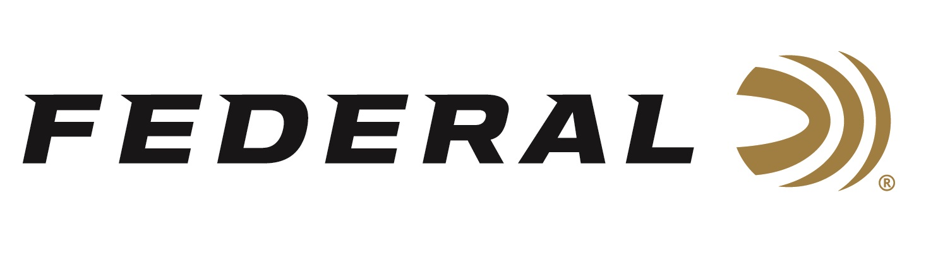

FOR IMMEDIATE RELEASE

Episode No. 2 of Federal Ammunition’s “It’s Federal Season” Podcast

ANOKA, Minnesota – January 20, 2020 – SHOT Show is the topic of Federal Ammunition’s January release of “It’s Federal Season,” a podcast dedicated to everything ammunition. The second episode will be live for downloading on January 20, 2020 coinciding with the first day of SHOT Show and can be downloaded from www.federalpremium.com/podcast.

Federal ammunition will be in Booth No. 14551 at the 2020 SHOT Show, January 21-24 at the Sands Expo Center in Las Vegas, Nevada.

“SHOT Show is a celebration of the firearms industry and we wanted to give some insights to Federal’s annual approach at this important trade show,” says Sr. Director of Marketing Jason Nash. In the Tech Talk segment, Muzzleloader Product Manager Dan Compton covers all the details about the launch of FireStick. This new muzzleloader system, in partnership with Traditions, will revolutionize the muzzleloader category and Dan covers all the advantages this new product will provide enthusiasts.

Before signing off, find out what’s new for apparel on the www.federalpremium.com website and information on upcoming events where consumers can meet with our ammunition team to talk all things ammunition. Also look for more information about “It’s Federal Season” podcast at www.federalpremium.com/podcast or where you find your favorite podcasts.

Federal ammunition can be found at dealers nationwide or purchased online direct from Federal. For more information on all products from Federal or to shop online, visit www.federalpremium.com.

Press Release Contact: JJ Reich
Senior Manager – Press Relations
E-mail: VistaPressroom@VistaOutdoor.com

About Federal Ammunition
Federal, headquartered in Anoka, MN, is a brand of Vista Outdoor Inc., an outdoor sports and recreation company. From humble beginnings nestled among the lakes and woods of Minnesota, Federal Ammunition has evolved into one of the world's largest producers of sporting ammunition. Beginning in 1922, founding president, Charles L. Horn, paved the way for our success. Today, Federal carries on Horn's vision for quality products and service with the next generation of outdoorsmen and women. We maintain our position as experts in the science of ammunition production. Every day we manufacture products to enhance our customers' shooting experience while partnering with the conservation organizations that protect and support our outdoor heritage. We offer thousands of options in our Federal Premium and Federal® lines-it's what makes us the most complete ammunition company in the business and provides our customers with a choice no matter their pursuit.

