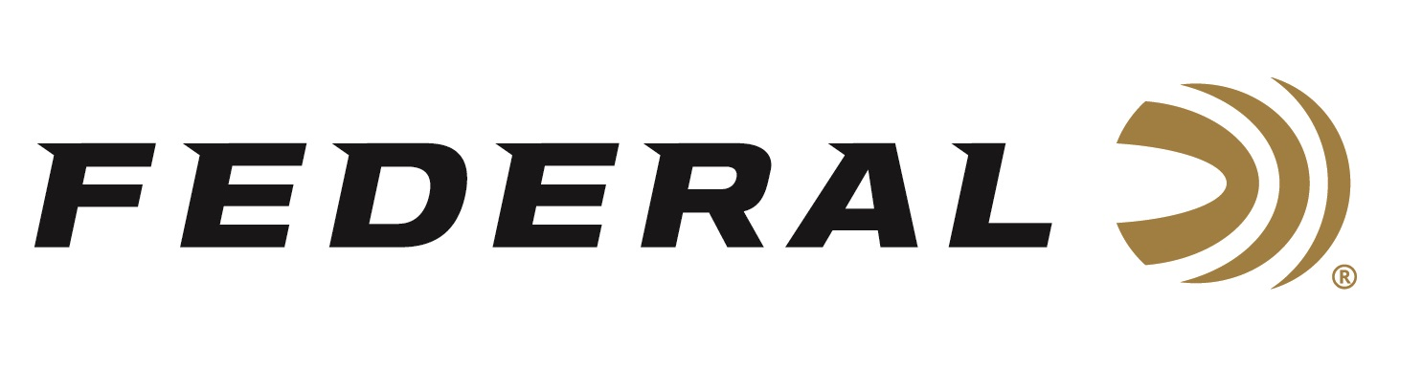

FOR IMMEDIATE RELEASE

The 2020 Federal Kubota Sweepstakes Contest Going Strong

ANOKA, Minnesota – April 21, 2020 – Whether it be deer or ducks, bulls or bears, scouting or sighting in: Federal Season is always in full swing. That is why Federal teamed with Kubota to give away a SideKick UTV that gets you, your gear and Federal Premium ammunition to the range, the field, and everywhere in between.

“We are very excited about this Sweepstakes, as it is one of the biggest prize packages Federal has ever done,” said Federal’s Sr. Brand Manager Brian Anderson. “Kubota is a great company with high quality products, and we are proud our brands have engaged together for this valuable giveaway.”

The SideKick UTV grand prize package also includes a big Federal-branded merchandise package including a shirt, hat, gun case, campfire ring and much more. Those entering can also opt-in to receive periodic emails about new products and special offers from Federal and Kubota.

The 2020 Federal Kubota Sweepstakes is open and offered only to current legal residents of the 48 contiguous United States and District of Columbia, who are at least 18 years of age or older (or 19 for residents of Alabama and Nebraska) at the time of entry. The Sweepstakes started at on April 14, 2020 and ends on July 31, 2020. The Random Drawing will take place on or about August 5, 2020. No purchase necessary. Limit one entry per entrant.

For details on how to enter, complete eligibility requirements, prizes, odds of winning, and full official rules, visit www.FederalKubotaSweeps.com.

Federal ammunition can be found at dealers nationwide or purchased online direct from Federal. For more information on all products from Federal or to shop online, visit www.federalpremium.com.

Press Release Contact: JJ Reich
Senior Manager – Press Relations
E-mail: VistaPressroom@VistaOutdoor.com

About Federal Ammunition
Federal, headquartered in Anoka, MN, is a brand of Vista Outdoor Inc., an outdoor sports and recreation company. From humble beginnings nestled among the lakes and woods of Minnesota, Federal Ammunition has evolved into one of the world's largest producers of sporting ammunition. Beginning in 1922, founding president, Charles L. Horn, paved the way for our success. Today, Federal carries on Horn's vision for quality products and service with the next generation of outdoorsmen and women. We maintain our position as experts in the science of ammunition production. Every day we manufacture products to enhance our customers' shooting experience while partnering with the conservation organizations that protect and support our outdoor heritage. We offer thousands of options in our Federal Premium and Federal® lines-it's what makes us the most complete ammunition company in the business and provides our customers with a choice no matter their pursuit.

