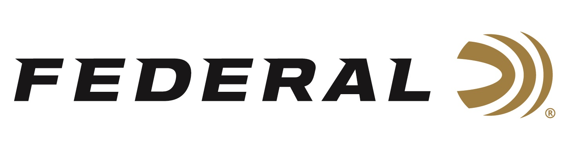

FOR IMMEDIATE RELEASE

Federal Kubota Sweepstakes Winner Hails from the Lone Star State

ANOKA, Minnesota – October 9, 2020 – Chon Martinez of Anderson, Texas is the winner of the 2020 Federal Kubota Sweepstakes. Martinez drives away with a Federal branded Kubota Sidekick utility vehicle, with accessories, and gear from Federal and Kubota worth more than $23,000. Martinez and his family picked up the keys to the new Sidekick on Saturday following a ceremony at the WC Tractor dealership in Navasota, Texas.

“The Sweepstakes was a great success,” says Brian Anderson, Federal’s Director of Marketing. “The amount of entries exceeded our expectations and it’s exciting to award the largest prize package in Federal’s history to a hunter that will use the Federal Ammunition branded UTV and prizes in pursuit of wild game,” stated Anderson.

Martinez, a farmer and rancher, stated the Kubota Sidekick, built for durability and speeds of up to 40 mph, will be used on his country property for transportation, grounds care, hauling and hunting and he expects to trailer it as well for additional hunting purposes. The grand prize package also included a Federal-branded merchandise package including a shirt, hat, gun case, campfire ring and much more.

“This sweepstakes was a great opportunity for any hunter to really step up their game as it brought together Federal’s world-class ammunition and Kubota’s ultimate hunting utility vehicle,” said Jacob Mandoza, Kubota senior product manager for utility vehicles. “We’re excited for Mr. Martinez to put his Sidekick’s speed and performance to the test in the field and we wish him well this hunting season and for many more to come.”

The 2020 Federal Kubota Sweepstakes was open and offered only to current legal residents of the 48 contiguous United States and District of Columbia, who are at least 18 years of age or older (or 19 for residents of Alabama and Nebraska) at the time of entry. The Sweepstakes started at on April 14, 2020 and ended on July 31, 2020. The Random Drawing took place in August. No purchase was necessary, and entrants were limited to one entry.

Federal ammunition can be found at dealers nationwide or purchased online direct from Federal. For more information on all products from Federal or to shop online, visit www.federalpremium.com.

To learn more about Kubota, visit KubotaUSA.com.
Photo Caption: Chon Martinez of Anderson, Texas, and his wife, Mary, stand in front of a Federal-branded Kubota Sidekick utility vehicle he won through the 2020 Federal Kubota Sweepstakes.

Press Release Contact: JJ Reich
Senior Manager – Press Relations
E-mail: VistaPressroom@VistaOutdoor.com

About Federal Ammunition
Federal, headquartered in Anoka, MN, is a brand of Vista Outdoor Inc., an outdoor sports and recreation company. From humble beginnings nestled among the lakes and woods of Minnesota, Federal Ammunition has evolved into one of the world's largest producers of sporting ammunition. Beginning in 1922, founding president, Charles L. Horn, paved the way for our success. Today, Federal carries on Horn's vision for quality products and service with the next generation of outdoorsmen and women. We maintain our position as experts in the science of ammunition production. Every day we manufacture products to enhance our customers' shooting experience while partnering with the conservation organizations that protect and support our outdoor heritage. We offer thousands of options in our Federal Premium and Federal® lines-it's what makes us the most complete ammunition company in the business and provides our customers with a choice no matter their pursuit.

