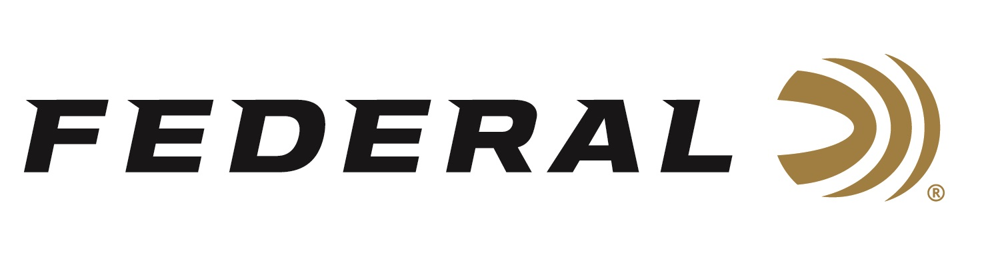

FOR IMMEDIATE RELEASE

Federal Ammunition Introduces New MSR Ammo Cans

ANOKA, Minnesota – February 24, 2020 – Federal ammunition adds to its bulk ammo lineup with three new 420-count packs of 223 Rem. and 5.56x45mm FMJ to keep range time going strong all day long. Shipments of this new product have begun to arrive at dealers.

Available in 223 Rem. and 5.56x45mm 55-grain or 5.56x45mm 62-grain, the three new offerings hold 420 rounds of consistent, accurate target loads in a rugged metal ammo can. All feature quality bullets, reloadable brass cases and dependable primers.

Features
- Heavy-duty metal ammo cans
- Accurate and reliable target ammunition
- Mil-spec primers
- Military grade and American made

Part No. / Description / MSRP
AE223BK420 AC1 / 223 Rem. 55-grain FMJ-BT, 3240 fps, .269 BC / $249.99
XM193BK420 AC1 / 5.56x45mm 55-grain FMJ-BT, 3165 fps, .246 BC / $249.99
XM855BK420 AC1 / 5.56x45mm 62-grain FMJ-BT, 3020 fps, .349 BC / $254.99

Federal ammunition can be found at dealers nationwide or purchased online direct from Federal. For more information on all products from Federal or to shop online, visit www.federalpremium.com.

Press Release Contact: JJ Reich
Senior Manager – Press Relations
E-mail: VistaPressroom@VistaOutdoor.com

About Federal Ammunition
Federal, headquartered in Anoka, MN, is a brand of Vista Outdoor Inc., an outdoor sports and recreation company. From humble beginnings nestled among the lakes and woods of Minnesota, Federal Ammunition has evolved into one of the world's largest producers of sporting ammunition. Beginning in 1922, founding president, Charles L. Horn, paved the way for our success. Today, Federal carries on Horn's vision for quality products and service with the next generation of outdoorsmen and women. We maintain our position as experts in the science of ammunition production. Every day we manufacture products to enhance our customers' shooting experience while partnering with the conservation organizations that protect and support our outdoor heritage. We offer thousands of options in our Federal Premium and Federal® lines-it's what makes us the most complete ammunition company in the business and provides our customers with a choice no matter their pursuit.

