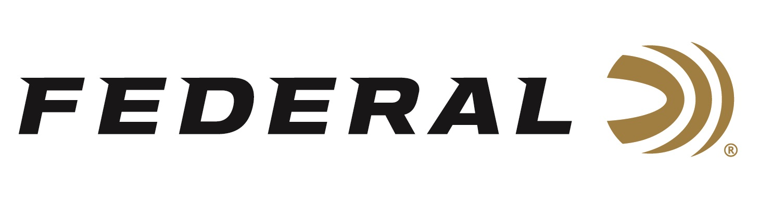

FOR IMMEDIATE RELEASE

Federal Ammunition Introduces New MeatEater Bismuth Loads for Waterfowl and Upland Hunting

ANOKA, Minnesota – June 5, 2020 – Bring back the performance of lead—without the heavy metal—with new Federal Premium Bismuth, the freezer-filler shotshell ammunition of MeatEater's Steven Rinella. This new line of ammunition features high-quality 9.6 g/cc density bismuth pellets. Its payloads pattern and hit birds like traditional lead, providing more killing power at longer ranges. Twelve cartridge options are available in the new Bismuth product line. Options span from 12-gauge, 3- and 2 3/4-inch to 20-gauge, 3-inch in shot sizes of 3, 4, or 5. Shipments of this new product have begun to arrive at dealers.

Memories and a meal are riding on every hunt. No one knows this better than MeatEater’s Steven Rinella, who travels the world looking to put wild game on his plate. Federal has partnered with the conservationist, author and hunter on this exclusive new line of Bismuth shotshell ammunition. Look for Rinella's photo on the box, along with one of his own mouth-watering wild game recipes.

“Our Federal Premium Bismuth’s impressive ability to effectively harvest upland game and waterfowl, due to its dense material construction, is what our customers love about it the most. Bismuth is also legal on public lands for all upland game and waterfowl, so it is a popular steel-shot alternative,” said Federal Shotshell Product Director Rick Stoeckel. “And as a bonus, Grandpa’s old shotgun isn’t limited to just the trap range anymore. It could be used on a hunt, without the worry of damaging it with steel shot.”

Federal Premium Bismuth shot is softer than tungsten and steel, allowing use in older shotguns as well as modern guns. The loads’ FLITECONTROL FLEX wad tightens patterns and increases lethality over comparable steel loads. This ammunition provides enhanced performance over steel that some waterfowl and upland hunters are seeking.

Features
- New Premium payloads of high-quality 9.6 g/cc bismuth pellets
- Shot is almost as dense as lead for greater lethality at longer ranges than steel
- Meets non-toxic requirements for waterfowl and upland hunting
- Bismuth is safe and effective for use in all shotguns
- FLITECONTROL FLEX wad for dense, consistent patterns
- Consistent, reliable components and Federal’s lead-free Catalyst primer
Part No. / Description / MSRP
PBIX137 3 / 12 gauge 3 inch 1 3/8 ounce 3 Bismuth / $71.99
PBIX137 4 / 12 gauge 3 inch 1 3/8 ounce 4 Bismuth / $71.99
PBIX137 5 / 12 gauge 3 inch 1 3/8 ounce 5 Bismuth / $71.99
PBIX144 3 / 12 gauge 2 3/4 inch 1 1/4 ounce 3 Bismuth / $65.99
PBIX144 4 / 12 gauge 2 3/4 inch 1 1/4 ounce 4 Bismuth / $65.99
PBIX144 5 / 12 gauge 2 3/4 inch 1 1/4 ounce 5 Bismuth / $65.99
PBIX244 3 / 20 gauge 3 inch 1 1/8 ounce 3 Bismuth / $62.99
PBIX244 4 / 20 gauge 3 inch 1 1/8 ounce 4 Bismuth / $62.99
PBIX244 5 / 20 gauge 3 inch 1 1/8 ounce 5 Bismuth / $62.99

Federal ammunition can be found at dealers nationwide or purchased online direct from Federal. For more information on all products from Federal or to shop online, visit www.federalpremium.com.

Press Release Contact: JJ Reich
Senior Manager – Press Relations
E-mail: VistaPressroom@VistaOutdoor.com

About Federal Ammunition
Federal, headquartered in Anoka, MN, is a brand of Vista Outdoor Inc., an outdoor sports and recreation company. From humble beginnings nestled among the lakes and woods of Minnesota, Federal Ammunition has evolved into one of the world's largest producers of sporting ammunition. Beginning in 1922, founding president, Charles L. Horn, paved the way for our success. Today, Federal carries on Horn's vision for quality products and service with the next generation of outdoorsmen and women. We maintain our position as experts in the science of ammunition production. Every day we manufacture products to enhance our customers' shooting experience while partnering with the conservation organizations that protect and support our outdoor heritage. We offer thousands of options in our Federal Premium and Federal® lines-it's what makes us the most complete ammunition company in the business and provides our customers with a choice no matter their pursuit.

