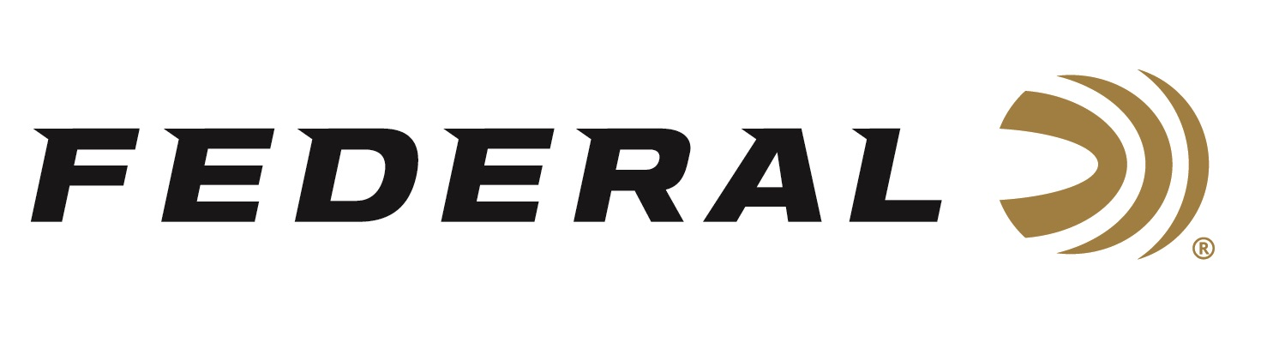

FOR IMMEDIATE RELEASE

Federal Awarded High-Performance Ammunition Contract for US Army Next Generation Carbine Technologies Program

ANOKA, Minnesota – July 31, 2020 – Federal Ammunition is proud to announce a contract award to supply high-performance 7.62x51mm NATO and other novel ammunition for the U.S. Army’s Next Generation Carbine Technologies (NGCT) program. This suite of ammunition utilizes a specialized alloy cartridge case allowing for elevated chamber pressures and a reduction in ammunition weight as compared to legacy brass-cased ammunition. These performance benefits deliver a significant increase in overall weapon system effectiveness for the NGCT program.

“We are a company committed to providing ammunition support to the U.S. military, as defined through our mission statement to ‘Build better ammunition in America, to create community, power defense, and conserve our heritage’,” said Jason Vanderbrink, President of Federal Ammunition. “We are extremely pleased with this prestigious contract award, as it validates the high level of trust the U.S. military has with our new and innovative products.”

“Our use of a proprietary high-performance alloy cartridge case will provide the U.S. Army NGCT Team with an excellent ammunition platform for evaluation of advanced Next Generation weapon concept performance. Program results will serve to inform the direction of future Next Generation weapon technology decisions for the U.S. Army,” said David Leis, Federal’s VP of Law Enforcement, Government and International Sales. “Ammunition products utilizing this specialized alloy cartridge case technology will be made available for commercial and foreign sales in the near future.”

Federal ammunition can be found at dealers nationwide or purchased online direct from Federal. For more information on all products from Federal or to shop online, visit www.federalpremium.com.

Press Release Contact: JJ Reich
Senior Manager – Press Relations
E-mail: VistaPressroom@VistaOutdoor.com

About Federal Ammunition
Federal, headquartered in Anoka, MN, is a brand of Vista Outdoor Inc., an outdoor sports and recreation company. From humble beginnings nestled among the lakes and woods of Minnesota, Federal Ammunition has evolved into one of the world's largest producers of sporting ammunition. Beginning in 1922, founding president, Charles L. Horn, paved the way for our success. Today, Federal carries on Horn's vision for quality products and service with the next generation of outdoorsmen and women. We maintain our position as experts in the science of ammunition production. Every day we manufacture products to enhance our customers' shooting experience while partnering with the conservation organizations that protect and support our outdoor heritage. We offer thousands of options in our Federal Premium and Federal® lines-it's what makes us the most complete ammunition company in the business and provides our customers with a choice no matter their pursuit.

