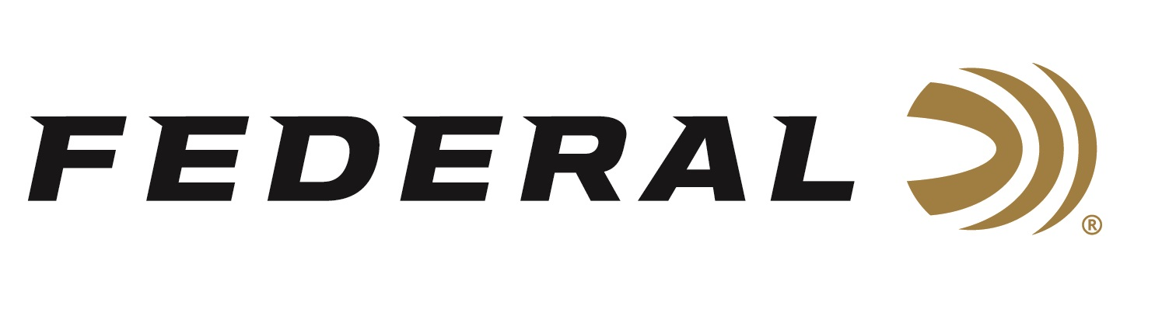
FOR IMMEDIATE RELEASE

Competitive Sporting Clays Shooter Derrick Mein Joins Team Federal and Wins NSCA Championship

ANOKA, Minnesota – October 27, 2020 – Federal Ammunition sponsored shooters shined at the 2020 National Sporting Clays Championship, October 17-25, 2020 at the National Shooting Complex in San Antonio, Texas. Derrick Mein, the newest Team Federal member, topped the podium as High Over All (HOA) and Janet McDougall took home Runner-Up honors in the Main Lady Event.

Mein shot Gold Medal Paper to top the podium as HOA with an aggregate score of 288 of 300 in the Main Event, taking home the prize of $10,000.

“Mein is certainly one of the top shooters in the world and has been burning up the circuit all summer long in multiple disciplines. He will also be one of the first men’s trap shooters to represent the U.S.A.—in Tokyo July of 2021—in more than 12 years,” said Federal’s Vice President of Marketing Jason Nash. “We are certainly proud to now have him shooting Federal. We are eager and excited to see his long list of career wins and accomplishments grow even larger with our products.”

Also placing high in the tournament was Federal Team member Janet McDougall. She won Runner-Up with an aggregate score of 268 of 300 in the Main Lady Event. She was just one bird off the lead and was the only lady competitor to shoot two rounds in the 70s.

“These events often boil down to confidence and concentration,” said McDougall. “Federal Premium Gold Medal delivers the confidence, but the concentration is up to me. For this event, I choose the 1-1/8-ounce, 1,235-fps loads. Just that little bit of increased payload and velocity gave me extra confidence between my ears. Going into the last stage, I knew my Gold Medal would reliably do its job to deliver clean breaks. All I needed to do is get my mind set right and concentrate on shot placement. It all worked out and I was quite happy with the results.”

“Other Team Federal members had strong showings, including Olympic Team member Kayle Browning and Team Federal members Forrest Montealegre, Tom Mack and Gary Greenway,” said Nash. “We congratulate all shooters on Team Federal with a job well done.”

Federal is the official shotshell ammunition sponsor and supplier of USA Shooting, a non-profit organization that promotes the shooting sports and prepares American athletes to bring home gold. Federal is also a large supporter of the Amateur Trap Association (ATA), National Skeet Shooters Association (NSSA), National Sporting Clays Association (NSCA), and many other national, regional and state shooting sports organizations.

Federal ammunition can be found at dealers nationwide or purchased online direct from Federal. For more information on all products from Federal or to shop online, visit www.federalpremium.com.

Press Release Contact: JJ Reich
Senior Manager – Press Relations
E-mail: VistaPressroom@VistaOutdoor.com

About Federal Ammunition
Federal, headquartered in Anoka, MN, is a brand of Vista Outdoor Inc., an outdoor sports and recreation company. From humble beginnings nestled among the lakes and woods of Minnesota, Federal Ammunition has evolved into one of the world's largest producers of sporting ammunition. Beginning in 1922, founding president, Charles L. Horn, paved the way for our success. Today, Federal carries on Horn's vision for quality products and service with the next generation of outdoorsmen and women. We maintain our position as experts in the science of ammunition production. Every day we manufacture products to enhance our customers' shooting experience while partnering with the conservation organizations that protect and support our outdoor heritage. We offer thousands of options in our Federal Premium and Federal® lines-it's what makes us the most complete ammunition company in the business and provides our customers with a choice no matter their pursuit.

