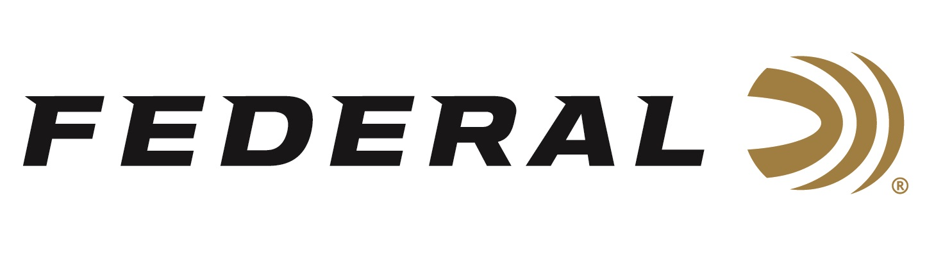

FOR IMMEDIATE RELEASE

Federal Expands Syntech Options for Target Shooters and Personal Defenders

ANOKA, Minnesota – January 15, 2020 – Federal’s Syntech changed the landscape of target ammunition when it launched its all-new Range ammunition, and now Federal—the largest ammunition manufacturer in the world—expands its Syntech family of products. Federal’s latest offerings include new Practice & Defend Packs and Federal Premium Solid Core featuring Syntech technology.

These new products will be announced and on display in Booth No. 14551 at the 2020 SHOT Show, January 21-24 at the Sands Expo Center in Las Vegas, Nevada. The new Practice & Defend Packs are shipping in January 2020 and Federal Premium Solid Core is scheduled to start shipping in the Spring of 2020.

The original 2017 product launch of Federal’s Syntech Range ammunition included 9mm Luger 115-grain; 40 S&W 165-grain; and 45 Auto 230-grain. Its polymer-encapsulated Syntech bullet prevents metal-on-metal contact between the bullet and bore, while eliminating copper and lead fouling. Combined with specialized clean-burning powders, your gun will stay cleaner, longer, so you can shoot more—and shoot better. The exclusive Catalyst primer provides the cleanest most consistent ignition possible—that’s why it received the 2017 NRA Golden Bullseye Award.

Since then, the company has greatly expanded its Syntech product offerings beyond ammo to smack targets at the range. Federal’s Syntech ammunition now include several training, self-defense, competition and specialty options. In 2018, the company expanded the product line by introducing a 9mm Luger 124-grain option. In that same year, Federal introduced Syntech Action Pistol. In 2019, Federal introduced Syntech Defense, Syntech Pistol Caliber Carbine (PCC) and Syntech Training Match.

“New for 2020, we are adding a 148-grain, 38 Special load to the original Syntech Range product line. And we are also offering new combination packs that paired Syntech Training Match with HST Personal Defense together as one product,” explained Federal Product Director Mike Holm. “Last but not least, we are introducing Solid Core which is a Federal Premium-branded product featuring hard cast bullets that utilize Syntech technology. These high-end loads are intended for hunting or as self-defense against possible dangerous animals when out hiking or camping in the wild.”

New Practice & Defend Packs pair self-defense loads proven by law enforcement with ballistically identical training ammunition for a combination like no other. These convenient combo packs include 50 HST Personal Defense loads and 50 Syntech Training Match rounds. All produce identical velocities, trajectories and point of impact for the most realistic training and utmost protection. It is available in four product options including two options in 9mm Luger, plus an option in 40 S&W and 45 Auto.

New Federal Premium Solid Core can take down anything from hogs to bears. The all-new line of handgun loads hits game harder with a tough, flat-nose lead bullet that holds together while blowing through bone, providing high weight retention and deep penetration. Syntech polymer jacket technology reduces the friction and leading that plague hard cast bullets. This deep-penetrating, hard bullet holds together while blowing through bone. It is intended for hunting, and as protection against dangerous animals. Solid Core is available in six offerings ranging from 9mm Luger to 44 Rem. Magnum.

“It’s all about having a better shooting experience. With range time so precious to all of us, it only makes sense to choose ammunition that makes that time more fun and more productive, with less hassle and cleanup afterward,” said Holm. “With Syntech, you have it—more of what all shooters want, and less of what you don’t.”

For more information on all products from Federal, visit www.federalpremium.com.

Press Release Contact: JJ Reich
Senior Communications Manager - Ammunition
E-mail: VistaPressroom@VistaOutdoor.com

About Federal Ammunition
Federal, headquartered in Anoka, MN, is a brand of Vista Outdoor Inc., an outdoor sports and recreation company. From humble beginnings nestled among the lakes and woods of Minnesota, Federal Ammunition has evolved into one of the world's largest producers of sporting ammunition. Beginning in 1922, founding president, Charles L. Horn, paved the way for our success. Today, Federal carries on Horn's vision for quality products and service with the next generation of outdoorsmen and women. We maintain our position as experts in the science of ammunition production. Every day we manufacture products to enhance our customers' shooting experience while partnering with the conservation organizations that protect and support our outdoor heritage. We offer thousands of options in our Federal Premium and Federal® lines-it's what makes us the most complete ammunition company in the business and provides our customers with a choice no matter their pursuit.

