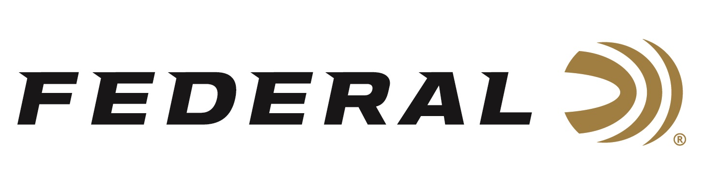

FOR IMMEDIATE RELEASE

**Federal Ammunition Introduces PUNCH: It’s Newest Defensive Handgun Option for Personal Defenders**

**ANOKA, Minnesota – May 20, 2020 –** New Punch draws from Federal Ammunition’s decades of experience designing the world’s finest defensive handgun loads. The bullet’s skived jacket and soft lead core produce the best expansion and penetration in its class, while its nickel-plated brass and sealed primer deliver the reliable feeding and ignition needed for powerful personal protection. Now available in the top five, most popular, self-defense chamberings on the market. Shipments of this product have begun to arrive at dealers.

“Simply put, we know more about making duty and defensive bullets than anyone,” said Federal Handgun Ammunition Product Manager Chris Laack. “We used that knowledge and experience to create a product to specifically meet the needs of self-defense with a handgun. The result of that hard work is Punch.”

Rather than developing a single bullet design for all five loads, the team at Federal evaluated each caliber individually and determined which bullet design and weight would work most effectively for each load. Since the bullets weren’t specifically designed to perform in FBI protocol testing, Laack and his team spent time tuning each Punch load to meet the needs of the self-defense shooter—namely reliable expansion and enough penetration.

“We looked at specifications from our Hydra-Shok Deep, HST and other bullet designs, and took what made sense for Punch,” said Laack. “We selected whatever elements worked best for each individual caliber. We then played with thickness of the jacket, skive depth, hollow point geometry and even differences in lead cores to build the recipe for Punch.”

The result is a blend of good overall performance from a Federal Premium bullet that was designed specifically for the most common self-defense applications such as an extra-heavy clothing test using ballistic gel.

“The fact that that we're launching Punch in the top five, most popular, self-defense chamberings on the market—all at once—makes a statement,” said Laack. “Typically, a new self-defense ammunition is launched in only one or two calibers then others are added later. But not Punch, we believe in it and know shooters looking for effective defensive ammunition with its specific features will love it.”

Also, in the build, Federal utilized nickel-plated cases, high quality powders, reliable primers with primer seal. Proven bullet profiles and geometry for reliable feeding.

**Features & Benefits**

* Jacketed hollow-point bullet design provides a balanced mix of effective penetration and expansion
* Out-performs comparably priced competitor rounds
* Nickel-plated brass case with primer seal
* Available in the most popular defensive handgun cartridges

**Part No. / Description / MSRP**

PD380P1 / 380 Auto 85-grain Punch JHP, 1,000 fps, 20-count / $15.99

PD38P1 / 38 Special +P, 120 grain Punch JHP, 1,070 fps, 20-count / $19.99

PD9P1 / 9mm Luger, 124 grain Punch JHP, 1,150 fps, 20-count / $15.99

PD40P1 / 40 S&W, 165 grain Punch JHP, 1,130 fps, 20-count / $21.99

PD45P1 / 45 Auto, 230 grain Punch JHP, 890 fps, 20-count / $20.99

Federal ammunition can be found at dealers nationwide or purchased online direct from Federal. For more information on all products from Federal or to shop online, visit [www.federalpremium.com](http://www.federalpremium.com).

**Press Release Contact: JJ Reich**

Senior Manager – Press Relations

E-mail: [VistaPressroom@VistaOutdoor.com](mailto:VistaPressroom@VistaOutdoor.com)

**About Federal Ammunition**

Federal, headquartered in Anoka, MN, is a brand of Vista Outdoor Inc., an outdoor sports and recreation company. From humble beginnings nestled among the lakes and woods of Minnesota, Federal Ammunition has evolved into one of the world's largest producers of sporting ammunition. Beginning in 1922, founding president, Charles L. Horn, paved the way for our success. Today, Federal carries on Horn's vision for quality products and service with the next generation of outdoorsmen and women. We maintain our position as experts in the science of ammunition production. Every day we manufacture products to enhance our customers' shooting experience while partnering with the conservation organizations that protect and support our outdoor heritage. We offer thousands of options in our Federal Premium and Federal® lines-it's what makes us the most complete ammunition company in the business and provides our customers with a choice no matter their pursuit.