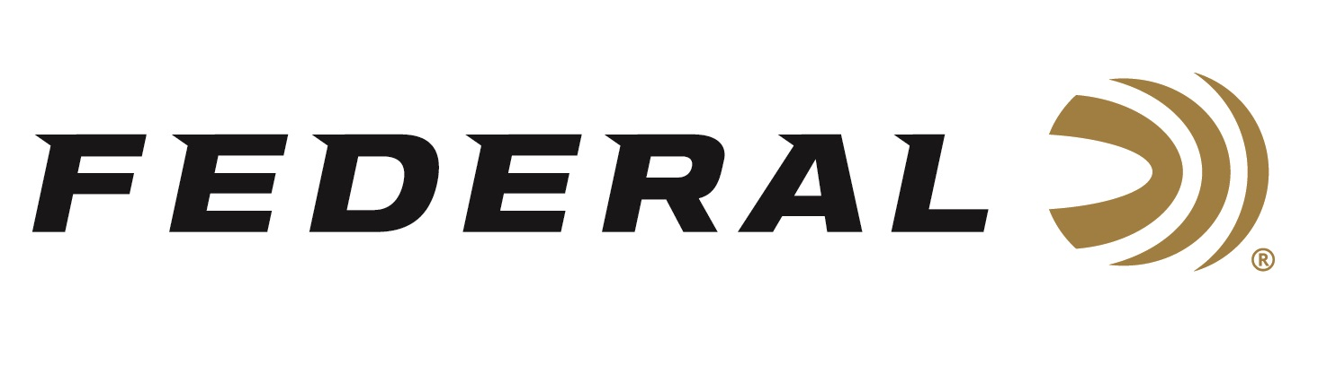

FOR IMMEDIATE RELEASE

Federal’s New Punch Personal Defense Ammo Delivers a Knockout

ANOKA, Minnesota – January 16, 2020 – Federal Ammunition has been a leading producer of law enforcement ammunition for more than thirty years. Drawing on that knowledge, the company recently set out to design a new self-defense load that would provide excellent overall performance from popular carry guns. The result of this effort is one of the most exciting new line of defensive loads to hit the market in years—Federal’s new Punch ammo.

This new line of ammunition will be on display in Booth No. 14551 at the 2020 SHOT Show, January 21-24 at the Sands Expo Center in Las Vegas, Nevada. New Federal Premium Punch is scheduled to ship at the end of January 2020.

Punch provides a great option for common self-defense scenario use—where performance through more complex duty barriers, like those in the FBI protocol test, are less likely to be a factor.

“Many personal defenders think, ‘If it works for law enforcement then it’s good for me.’ That is a great guideline and still our ultimate recommendation,” said Laack. “But that may add features not required for everyday carry for everyone.”

Federal saw a need for a reliable, accurate, terminally effective option that doesn’t have to be the top scoring product in duty ammunition test procedures.

“Concealed-carry permit holders, especially new shooters, need an uncomplicated answer to the question ‘What ammo do I need for self-defense’,” said Federal Handgun Ammunition Product Manager Chris Laack. “Things to consider such as function, reliable ignition, barrier performance, terminal performance, ballistics and other considerations are a lot to digest for most people. What some consumers really need to know is it will function in their gun, every time, and that it will be effective stopping a threat as quickly as possible. Punch is our easy answer for them.”

Most concealed carry permit holders are less concerned with factors such as barrier penetration through steel, plywood and auto glass and more concerned about choosing a bullet that is engineered from the ground-up to stop an attacker and work effectively in their chosen firearm. And, as the data shows, Punch bullets perform well in the tests that matter most to the average shooter—penetration and expansion through bare gel and heavy clothing. Federal has made Punch ammunition a natural choice for concealed carry.

What’s more, Punch ammunition features Federal’s smooth-feeding nickel-plated cases, advanced powders, and the sealed reliability of high-quality, sensitive primers. With Punch, self-defenders can be assured its components will do its job when it matters most.

The five new Punch options include a .380 Auto 85-grain offering with a muzzle velocity of 1,000 feet per second, a .38 Special +P 120-grain load at 1,070 fps, a 9mm 147-grain load at 1,150 fps, a .40 S&W 16-grain load at 1,130 fps, and a .45 Auto 230-grain load at 890 fps. What’s more, all these loads will be available immediately, and with MSRPs from $15.95 to $20.95 per box of 20.

Federal ammunition can be found at dealers nationwide or purchased online direct from Federal. For more information on all products from Federal or to shop online, visit www.federalpremium.com.

Press Release Contact: JJ Reich
Senior Manager – Press Relations
E-mail: VistaPressroom@VistaOutdoor.com

About Federal Ammunition
Federal, headquartered in Anoka, MN, is a brand of Vista Outdoor Inc., an outdoor sports and recreation company. From humble beginnings nestled among the lakes and woods of Minnesota, Federal Ammunition has evolved into one of the world's largest producers of sporting ammunition. Beginning in 1922, founding president, Charles L. Horn, paved the way for our success. Today, Federal carries on Horn's vision for quality products and service with the next generation of outdoorsmen and women. We maintain our position as experts in the science of ammunition production. Every day we manufacture products to enhance our customers' shooting experience while partnering with the conservation organizations that protect and support our outdoor heritage. We offer thousands of options in our Federal Premium and Federal® lines-it's what makes us the most complete ammunition company in the business and provides our customers with a choice no matter their pursuit.

