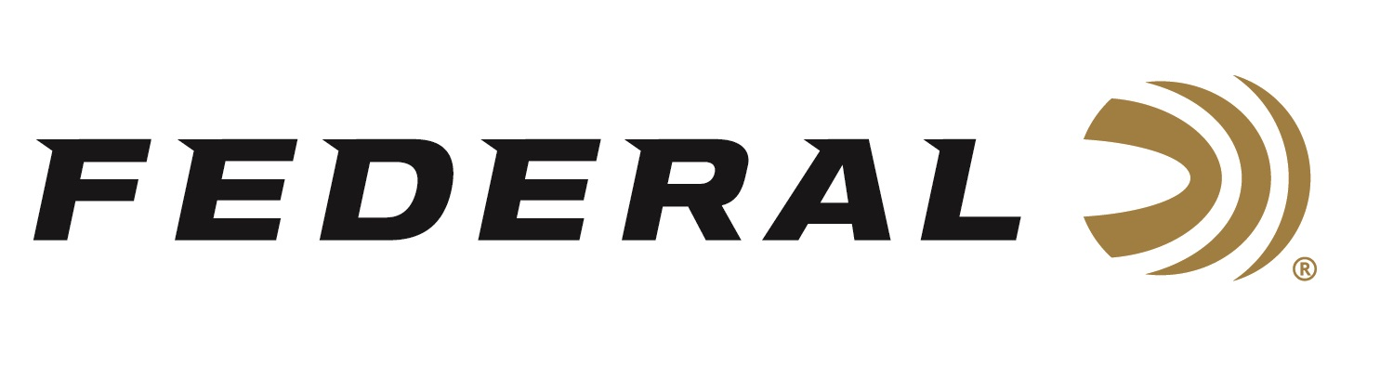

FOR IMMEDIATE RELEASE

Federal Ammunition and the Quality Deer Management Association Launch a Dedicated Partnership

ANOKA, Minnesota – May 8, 2020 – Federal Ammunition is proud to announce a strong promotional partnership with the Quality Deer Management Association (QDMA). The arrangement includes key representation at QDMA’s national Field to Fork events slated for Georgia in October and Texas planned for December 2020.

"We are excited to have Federal as a Field to Fork sponsor providing high quality ammunition for our program needs," said QDMA Assistant Director of Hunting Heritage Programs Hank Forester. "We've been amazed how quickly our Field to Fork hunters become diligent consumers of hunting equipment and how they remain loyal not only to the brands their taught with but to trusted advice from mentors. We're happy to introduce these new hunters with American-made Federal Ammunition.”

Quality Deer Management Association has more than 60,000 members in all 50 states. They are dedicated to ensuring the future of white-tailed deer, wildlife habitat and our hunting heritage. QDMA’s Field to Fork is a food-focused hunter recruitment program for adults from non-hunting backgrounds where participants engage in a season-long mentored hunting program that would teach them how to hunt and acquire a wild, healthy, local, sustainable source of food on their own. Learn more at https://www.qdma.com/recruit/field-to-fork/.

“QDMA’s Field to Fork is an industry-leading, food-focused hunter recruitment program. Choosing to use Federal’s reliable Non-Typical ammo at these events will provide the participants with a great bullet,” said Federal’s Director of Rifle Ammunition Mike Holm. “They will benefit from the accurate, soft-point bullet design and consistent components used in this load. It offers performance they can rely on. Plus, everyone will appreciate the red-white-and-blue, prideful packaging.”

The soft-shooting yet hard-hitting performance of the 7mm-08 Rem. cartridge has now been optimized for whitetails as a new option in the Federal Non-Typical line. Like all Non-Typical loads, the 7mm-08 Rem. uses a specially designed soft-point bullet with a concentric jacket to provide tag-filling accuracy and consistent, lethal wound channels on any whitetail.

Federal ammunition can be found at dealers nationwide or purchased online direct from Federal. For more information on all products from Federal or to shop online, visit www.federalpremium.com.

Press Release Contact: JJ Reich
Senior Manager – Press Relations
E-mail: VistaPressroom@VistaOutdoor.com

About Federal Ammunition
Federal, headquartered in Anoka, MN, is a brand of Vista Outdoor Inc., an outdoor sports and recreation company. From humble beginnings nestled among the lakes and woods of Minnesota, Federal Ammunition has evolved into one of the world's largest producers of sporting ammunition. Beginning in 1922, founding president, Charles L. Horn, paved the way for our success. Today, Federal carries on Horn's vision for quality products and service with the next generation of outdoorsmen and women. We maintain our position as experts in the science of ammunition production. Every day we manufacture products to enhance our customers' shooting experience while partnering with the conservation organizations that protect and support our outdoor heritage. We offer thousands of options in our Federal Premium and Federal® lines-it's what makes us the most complete ammunition company in the business and provides our customers with a choice no matter their pursuit.

