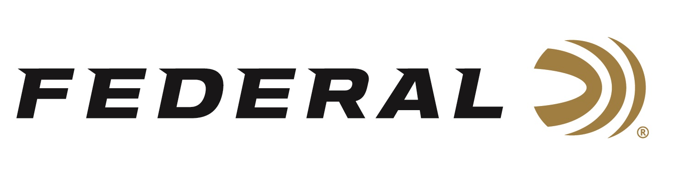

FOR IMMEDIATE RELEASE

Federal Sponsored Shooter Tucker Schmidt Wins the 2020 Pigg River Precision PRS Match

ANOKA, Minnesota – June 10, 2020 – Sponsored competitive shooter Tucker Schmidt takes home a title at the Pigg River Precision PRS Match in Rocky Mount, Virginia shooting Federal Premium Gold Medal 6mm Creedmoor.

“My rifle and ammunition combo were just hammering all weekend. I shot a really good match and was fortunate enough to leave with the win,” says Schmidt about his match victory. “As good as Federal factory-loaded Gold Medal ammo is, I’d just prefer not to spend hours in the garage reloading and just run it for the remainder of my matches.”

“The Federal Premium Gold Medal 6mm Creedmoor 107-grain Sierra Matchking shot with an average velocity of 3,090 feet-per-second (fps) and only a standard deviation of 7.5 fps,” Schmidt reported. “Sight-in accuracy at 100 yards was sub-1/2 MOA, and it shot consistently at any distance.”

“Tucker is new to our team this year. He shoots USPSA, 3-Gun and Precision Rifle Series for us and he’s naturally gifted in all the different disciplines,” said Federal Shooting Sports Promotions Manager Jason Spradling. “The message that I preach to all our shooters is that you don’t have to be a handloader to be competitive. You can shoot factory ammo and compete on a national level. In the past two years, we’ve had many top finishes with team members shooting our Gold Medal ammunition. Tucker’s finish at this event is proof of that, and we congratulate him.”

Gold Medal Sierra MatchKing 6mm Creedmoor features a boat-tail hollow-point bullet to provide ballistic performance match shooters need; uniform match jacket ensures consistent, long-range accuracy; quality Federal brass; specially formulated propellant; and a benchrest-quality Gold Medal primer. The exclusive primer design provides the best sensitivity and most consistent ballistics in the industry. The precision-built Sierra MatchKing bullet has won more matches than any other rifle bullet. It's the only choice for the world’s most elite shooters. Learn more at:
https://www.federalpremium.com/rifle/gold-medal/gold-medal-sierra-matchking/11-GM6CRDM1.html

Federal ammunition can be found at dealers nationwide or purchased online direct from Federal. For more information on all products from Federal or to shop online, visit www.federalpremium.com.
Photo Caption: Buck Holly, Tucker Schmidt, Noah Holly (All Team Federal) and Josh Bandy (Match Director and Owner of Pigg River Precision). Photo credit to Mission First Digital.

Press Release Contact: JJ Reich
Senior Manager – Press Relations
E-mail: VistaPressroom@VistaOutdoor.com

About Federal Ammunition
Federal, headquartered in Anoka, MN, is a brand of Vista Outdoor Inc., an outdoor sports and recreation company. From humble beginnings nestled among the lakes and woods of Minnesota, Federal Ammunition has evolved into one of the world's largest producers of sporting ammunition. Beginning in 1922, founding president, Charles L. Horn, paved the way for our success. Today, Federal carries on Horn's vision for quality products and service with the next generation of outdoorsmen and women. We maintain our position as experts in the science of ammunition production. Every day we manufacture products to enhance our customers' shooting experience while partnering with the conservation organizations that protect and support our outdoor heritage. We offer thousands of options in our Federal Premium and Federal® lines-it's what makes us the most complete ammunition company in the business and provides our customers with a choice no matter their pursuit.

