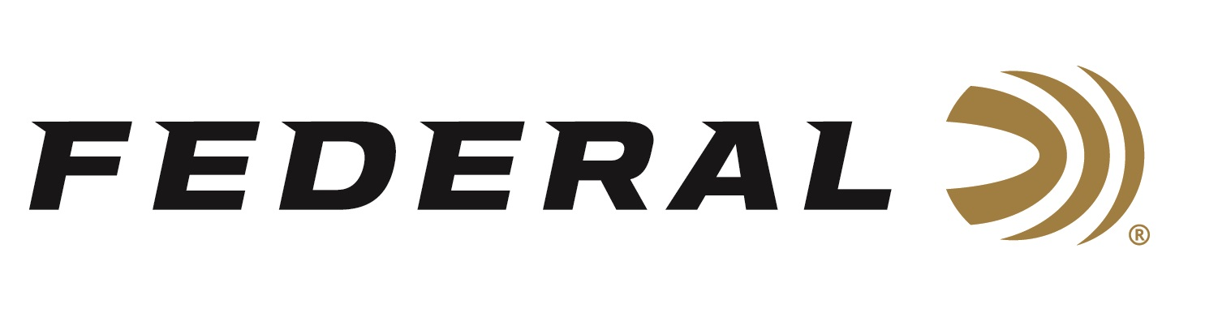

FOR IMMEDIATE RELEASE

NRA American Rifleman Magazine Honors Federal Premium
Terminal Ascent with “2021 Ammunition Product of the Year”
Golden Bullseye Award

ANOKA, Minnesota – December 15, 2020 – The National Rifle Association’s (NRA) American Rifleman magazine awarded Federal Premium Terminal Ascent with the Golden Bullseye Award for 2021 Ammunition Product of the Year. Federal will be honored with the achievement during a special reception at the 2021 NRA Annual Meetings & Exhibits on September 3-5, 2021 in Houston, Texas.

“We are truly honored by this prestigious award. We know that to qualify for consideration for a Golden Bullseye Award, the product must meet a variety of demanding criteria on design, function, value and overall contribution to the shooting industry,” said Federal’s President Jason Vanderbrink. “We are proud that our Terminal Ascent, the best hunting bullet we have ever produced in our 98-year history, delivered extreme reliability and performance that exceeded evaluators’ expectations during their rigorous field testing.”

Now in their 19th year, the NRA Publications Golden Bullseye Awards acknowledge the finest products available in the shooting sports. The winners are selected by a seven-member committee consisting of editors, graphic designers and veteran NRA Publications staff, representing more than a century of collective experience in the shooting and hunting industry.

The new Terminal Ascent blends the features of top match-style bullet designs with the industry’s best bonding technology and components to deliver any-range accuracy and reliable expansion even at low velocities. It’s innovative bullet design, featuring Federal’s Slipstream Tip and AccuChannel technologies, provide high weight retention, deep penetration and lethal terminal performance, both up close and at extreme long-range distances.

“Terminal Ascent features several key elements that make up its superior overall design. The result is outstanding, all-range terminal performance with both accuracy and reliability, plus it has great looks.” said Federal Centerfire and Handgun Ammunition Product Director Mike Holm. “In a marketplace filled with competitor loads that make tradeoffs—sacrificing short-range terminal performance for long-range expansion, or toughness for accuracy—Terminal Ascent does it all and stands alone.”

Federal ammunition can be found at dealers nationwide or purchased online direct from Federal. For more information on all products from Federal or to shop online, visit www.federalpremium.com.

Press Release Contact: JJ Reich
Senior Manager – Press Relations
E-mail: VistaPressroom@VistaOutdoor.com

About Federal Ammunition
Federal, headquartered in Anoka, MN, is a brand of Vista Outdoor Inc., an outdoor sports and recreation company. From humble beginnings nestled among the lakes and woods of Minnesota, Federal Ammunition has evolved into one of the world's largest producers of sporting ammunition. Beginning in 1922, founding president, Charles L. Horn, paved the way for our success. Today, Federal carries on Horn's vision for quality products and service with the next generation of outdoorsmen and women. We maintain our position as experts in the science of ammunition production. Every day we manufacture products to enhance our customers' shooting experience while partnering with the conservation organizations that protect and support our outdoor heritage. We offer thousands of options in our Federal Premium and Federal® lines-it's what makes us the most complete ammunition company in the business and provides our customers with a choice no matter their pursuit.

