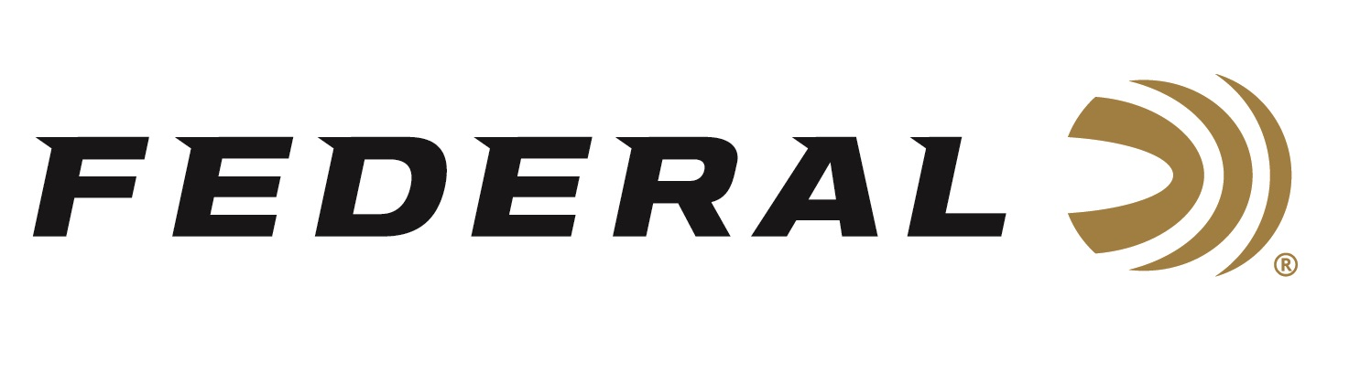

FOR IMMEDIATE RELEASE

Federal Premium Terminal Ascent Selected as Editors’ Choice in Shooting Sports Retailer

ANOKA, Minnesota – April 14, 2020 – Shooting Sports Retailer magazine recognized Federal Premium Terminal Ascent with an Editors’ Choice honor in a recent article published in its April 2020 issue. Federal considers its all-new Terminal Ascent as the best hunting bullet ever built within the 98-year history of the company due to several unique elements that make up its superior overall design.
The article reads: Federal Terminal Ascent's match-grade bonded bullet construction delivers deep penetration on close targets, while its patented Slipstream polymer tip helps flatten trajectory and initiates expansion at velocities 200 fps lower than comparable designs. The bullet's long, sleek profile offers and extremely high ballistic coefficient and its AccuChannel groove technology improves accuracy and minimized drag and wind drift. its copper shank and bonded lead core retain weight for deep penetration at any range. Terminal Ascent is available in a full selection of long-range hunting cartridges ranging from 6.5 Creedmoor to .300 WSM.
“We are proud the editors of Shooting Sports Retailer called out Terminal Ascent with this honor,” said Federal Centerfire Product Director Mike Holm. ““The new Terminal Ascent blends the features of top match-style bullet designs with the industry’s best bonding technology and components to deliver any-range accuracy and reliable expansion even at low velocities. Its outstanding bullet design provides high weight retention, deep penetration and lethal terminal performance, both up close and at extreme distances. We know the retailers will appreciate features and benefits and communicate these advantages to their own customer base.”

Shooting Sports Retailer provides the latest business news on gear, handguns, rifles, shotguns, optics, ammo and apparel. More than 13,000 outdoor hunting and shooting retailers rely on it to stay informed on the latest industry news and content.

Federal ammunition can be found at dealers nationwide or purchased online direct from Federal. For more information on all products from Federal or to shop online, visit www.federalpremium.com.

Press Release Contact: JJ Reich
Senior Manager – Press Relations
E-mail: VistaPressroom@VistaOutdoor.com

About Federal Ammunition
Federal, headquartered in Anoka, MN, is a brand of Vista Outdoor Inc., an outdoor sports and recreation company. From humble beginnings nestled among the lakes and woods of Minnesota, Federal Ammunition has evolved into one of the world's largest producers of sporting ammunition. Beginning in 1922, founding president, Charles L. Horn, paved the way for our success. Today, Federal carries on Horn's vision for quality products and service with the next generation of outdoorsmen and women. We maintain our position as experts in the science of ammunition production. Every day we manufacture products to enhance our customers' shooting experience while partnering with the conservation organizations that protect and support our outdoor heritage. We offer thousands of options in our Federal Premium and Federal® lines-it's what makes us the most complete ammunition company in the business and provides our customers with a choice no matter their pursuit.

