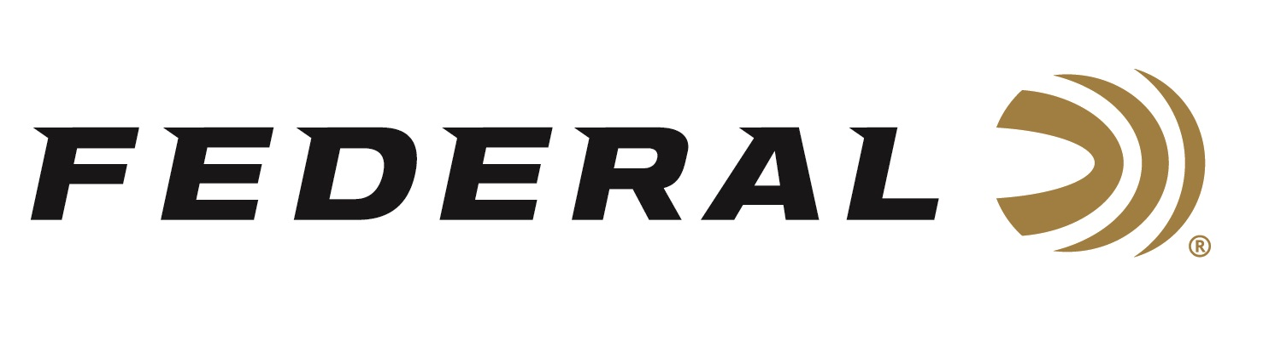
FOR IMMEDIATE RELEASE

Team Federal Sponsored Competitive Shooter Tim Herron Wins Single Stack Division at Area 2 USPSA Championship

ANOKA, Minnesota – November 12, 2020 – Federal Ammunition sponsored shooter Tim Herron won the Single Stack Division at the United States Practical Shooting Association (USPSA) Area 2 Championship. The match was held in Prescott, Arizona, November 5-8 at the beautiful Yavapai Recreation League and Prescott Action Shooters facility.

“I’m very pleased with a solid performance at this match, and I credit the smooth-running Federal American Eagle 45 Auto, 230-grain. It certainly helped me secure this big win with its exceptional accuracy and superb reliability,” said Herron. “I want to thank Federal for their continued overall support of the shooting sports and for the several years of supporting of me. I couldn’t do this without you.”

“We at Federal congratulate Tim on a great victory! He is a fierce competitor and a perfect example of the type of person we want representing Team Federal,” said Federal’s Shooting Sports Promotions Manager Jason Spradling. “There were twelve challenging courses of fire at this match, with everything from long-distance, 50-yard steel targets to multiple moving and activated targets. Earning the single-stack division win in such a difficult match against a group of top competitors is a huge accomplishment. We’re glad that Federal ammo could be part of the winning equation.”

Federal Ammunition is a sponsor of the USPSA, and Syntech Action Pistol is the official sponsored ammo of the organization, with their logo on the box. Learn more about the USPSA at www.uspsa.org.

Federal ammunition can be found at dealers nationwide or purchased online direct from Federal. For more information on all products from Federal or to shop online, visit www.federalpremium.com.

Press Release Contact: JJ Reich
Senior Manager – Press Relations
E-mail: VistaPressroom@VistaOutdoor.com

About Federal Ammunition
Federal, headquartered in Anoka, MN, is a brand of Vista Outdoor Inc., an outdoor sports and recreation company. From humble beginnings nestled among the lakes and woods of Minnesota, Federal Ammunition has evolved into one of the world's largest producers of sporting ammunition. Beginning in 1922, founding president, Charles L. Horn, paved the way for our success. Today, Federal carries on Horn's vision for quality products and service with the next generation of outdoorsmen and women. We maintain our position as experts in the science of ammunition production. Every day we manufacture products to enhance our customers' shooting experience while partnering with the conservation organizations that protect and support our outdoor heritage. We offer thousands of options in our Federal Premium and Federal® lines-it's what makes us the most complete ammunition company in the business and provides our customers with a choice no matter their pursuit.

