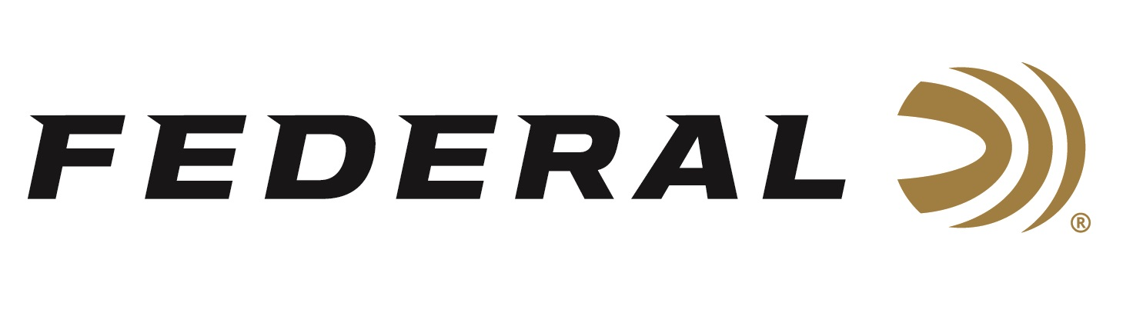

FOR IMMEDIATE RELEASE

Federal Ammunition Expands Its Top Gun Product Line with Two New Higher Velocity Options

ANOKA, Minnesota – March 23, 2020 – For decades, Top Gun loads have been pulverizing even the most challenging clay targets. New for 2020, two higher velocity (1,300 feet-per-second) loads have been added to the Top Gun product line. These are 1-ounce, 12-gauge, 2 ¾-inch loads in shot size 7.5 or 8. Shipments of this product have begun to arrive at dealers.

Now shooters can get that same trusted performance with Top Gun loads specifically designed for great performance in all applications of clay target shooting. They push their payloads fast to shorten leads yet reduce felt recoil to allow for quicker follow-up shots.

Features & Benefits
- New 1-ounce 12-gauge, 2 ¾-inch offerings
- Loads designed specifically for clays shooters
- High velocities at 1,300 fps, and less felt recoil
- Hard, quality pellets for breaking more clays
- Consistent, reliable Federal primer
- Unique wad column produces consistent patterns

Part No. / Description / MSRP
TGSH12 7.5 / 12 gauge 2 3/4 inch, 1 ounce, 1,300 fps, 7.5, 25-count / $9.99
TGSH12 8 / 12 gauge 2 3/4 inch 1 ounce, 1,300 fps, 8, 25-count / $9.99

Federal ammunition can be found at dealers nationwide or purchased online direct from Federal. For more information on all products from Federal or to shop online, visit www.federalpremium.com.

Press Release Contact: JJ Reich
Senior Manager – Press Relations
E-mail: VistaPressroom@VistaOutdoor.com

About Federal Ammunition
Federal, headquartered in Anoka, MN, is a brand of Vista Outdoor Inc., an outdoor sports and recreation company. From humble beginnings nestled among the lakes and woods of Minnesota, Federal Ammunition has evolved into one of the world's largest producers of ammunition. Beginning in 1922, founding president, Charles L. Horn, paved the way for our success. Today, Federal carries on Horn's vision for quality products and service with the next generation of outdoorsmen and women. We maintain our position as experts in the science of ammunition production. Every day we manufacture products to enhance our customers' shooting experience while partnering with the conservation organizations that protect and support our outdoor heritage. We offer thousands of options in our Federal Premium and Federal® lines-it's what makes us the most complete ammunition company in the business and provides our customers with a choice no matter their pursuit.

