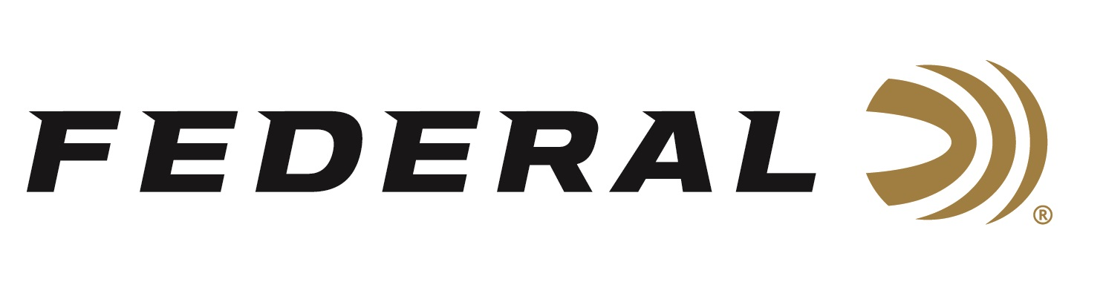

FOR IMMEDIATE RELEASE

Federal Ammunition Awarded $13.8 Million Delivery Order from the U.S. Army

ANOKA, Minnesota – July 29, 2020 – Federal Ammunition was recently given a new $13.8 million delivery order based on its contract awarded in 2017 by the U.S. Army. The order is for 5.56 NATO MK311 Frangible Ammunition, which is better known by ordnance code AA40. This military-grade, training ammunition has a 50-grain frangible bullet comprised of a non-toxic, copper and tungsten powder matrix core, and a gilding metal jacket. It disintegrates into small fragments on impact, minimizing over-penetration and ricochet hazards.

“One of the differentiators of AA40 is the use of Federal’s exclusive Catalyst primer. It’s a lead-free technology that provides the most reliable, consistent ignition possible,” said VP of Law Enforcement, Government and International Sales David Leis. “Unlike many other lead-free primer formulations, Catalyst primers have unique properties that allow them to be effectively and safely used in service ammunition. Catalyst primers have been used in hundreds of millions of rounds of ammunition delivered to military, law enforcement and commercial customers to-date.”

“We have a long history of providing high quality specialty ammunition to multiple branches of the U.S. military. Their continued trust is of the utmost importance to us, and is something we are certainly most proud of,” said Federal Ammunition President Jason Vanderbrink. “With this, Federal Ammunition continues to demonstrate surety of supply, professional capability, the ability to meet all specifications, and reliable delivery on production expectations of our military contracts.”

Federal ammunition can be found at dealers nationwide or purchased online direct. For more on Federal ammunition, visit www.federalpremium.com.

Press Release Contact: JJ Reich
Senior Communications Manager - Firearms and Ammunition
E-mail: VistaPressroom@VistaOutdoor.com

About Federal Ammunition
Federal, headquartered in Anoka, MN, is a brand of Vista Outdoor Inc., an outdoor sports and recreation company. From humble beginnings nestled among the lakes and woods of Minnesota, Federal Ammunition has evolved into one of the world's largest producers of sporting ammunition. Beginning in 1922, founding president, Charles L. Horn, paved the way for our success. Today, Federal carries on Horn's vision for quality products and service with the next generation of outdoorsmen and women. We maintain our position as experts in the science of ammunition production. Every day we manufacture products to enhance our customers' shooting experience while partnering with the conservation organizations that protect and support our outdoor heritage. We offer thousands of options in our Federal Premium and Federal® lines-it's what makes us the most complete ammunition company in the business and provides our customers with a choice no matter their pursuit.

