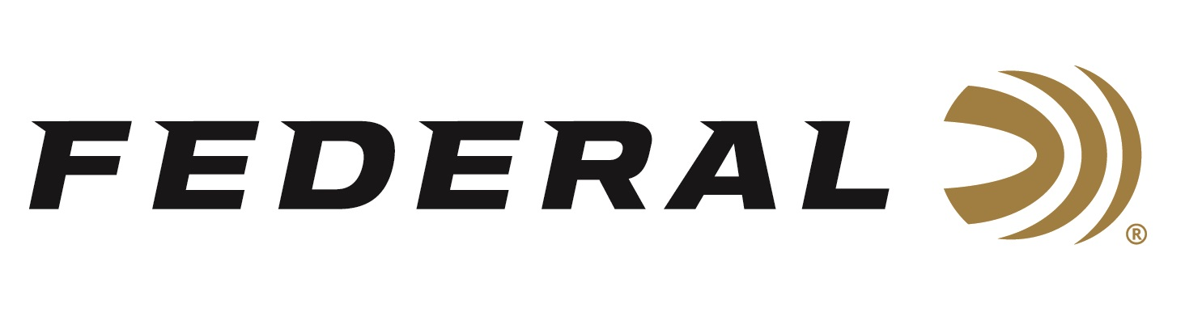

FOR IMMEDIATE RELEASE

Federal Launches Virtual Shows for Its Buy Group Partners and Distributors

ANOKA, Minnesota – August 7, 2020 – Federal developed a series of virtual sales shows to support its Buy Group customers. This effort is due to many of the industry’s sales shows being cancelled due to the COVID-19 pandemic. Starting on August 10, and running throughout the month, Federal will launch four virtual Buy Group shows for its business partners. Each Buy Group will receive its own dedicated week to review the digital content through an online portal. At the end of the week, attendees will get their questions answered by Federal’s sales staff and product teams through live chats.

“Our distributors and retailers are hungry for information and product news. They need to hear from us and since we cannot be there in person we created our own virtual experience,” said Federal SVP Hunting & Shooting Sales Jim Bruno. “As a result, our efforts will benefit the end consumer because we will provide the latest and greatest products and information to be made available from our distribution customers who attend these virtual shows.”

New product videos with detailed information on features and benefits will be the focus of the shows. Other digital content that will be provided include: messages from Federal Ammunition President Jason Vanderbrink and Senior Vice President of Sales Jim Bruno; examples of upcoming product advertising; trade marketing tools and displays; plus, pricing, terms and hot show specials for Buy Group members.

“We want attendees of our virtual shows to get the same access to assets that they would if they attended our booth at a physical show,” said Federal Events Director Michael Kinn. “During this challenging time, we needed to change our approach to how we do business, while still delivering everything our retail customers need to get our products in the hands of the end consumer. We know these virtual sales shows will deliver on that effort.”

New-for-2020 ammunition from Federal’s sister companies Speer and CCI will also be featured. Highlights include:
Federal Premium Terminal Ascent - Bonded construction penetrates deep, while the patented Slipstream polymer tip initiates expansion even at lower velocities and long range. AccuChannel groove technology improves accuracy and minimizes drag. Available in eleven of the most popular hunting cartridges and as component bullets.
Federal Premium Force X2 - Nine copper-plated 00 FX2 buckshot pellets split into two equal-size pieces on impact. Double the wound channels, improved energy transfer to the target, and less potential for over-penetration.
Speer Gold Dot Carry Gun - Speer has built upon the law-enforcement proven Gold Dot G2 bullet, optimizing the design and loading to provide superior feeding, ballistics and terminal performance through compact concealed handguns. Available in 9mm Luger 135-grain, 40 S&W 165-grain and 45 Auto +P 200-grain.

CCI MeatEater Series - CCI has partnered with MeatEater’s Steven Rinella on this exclusive new series of ammunition. CCI’s rimfire products available in this series includes Copper-22 22 LR 21-grain HP, Mini-Mag 22 LR, 36-grain CPHP and Maxi-Mag 22 WMR, 40-grain JHP.
Business customers and Buy Group members interested in more information on Federal’s virtual Buy Group shows should contact their Federal sales representative.

Federal ammunition can be found at dealers nationwide or purchased online direct from Federal. For more information on all products from Federal or to shop online, visit www.federalpremium.com.

Press Release Contact: JJ Reich
Senior Manager – Press Relations
E-mail: VistaPressroom@VistaOutdoor.com

About Federal Ammunition
Federal, headquartered in Anoka, MN, is a brand of Vista Outdoor Inc., an outdoor sports and recreation company. From humble beginnings nestled among the lakes and woods of Minnesota, Federal Ammunition has evolved into one of the world's largest producers of sporting ammunition. Beginning in 1922, founding president, Charles L. Horn, paved the way for our success. Today, Federal carries on Horn's vision for quality products and service with the next generation of outdoorsmen and women. We maintain our position as experts in the science of ammunition production. Every day we manufacture products to enhance our customers' shooting experience while partnering with the conservation organizations that protect and support our outdoor heritage. We offer thousands of options in our Federal Premium and Federal® lines-it's what makes us the most complete ammunition company in the business and provides our customers with a choice no matter their pursuit.

