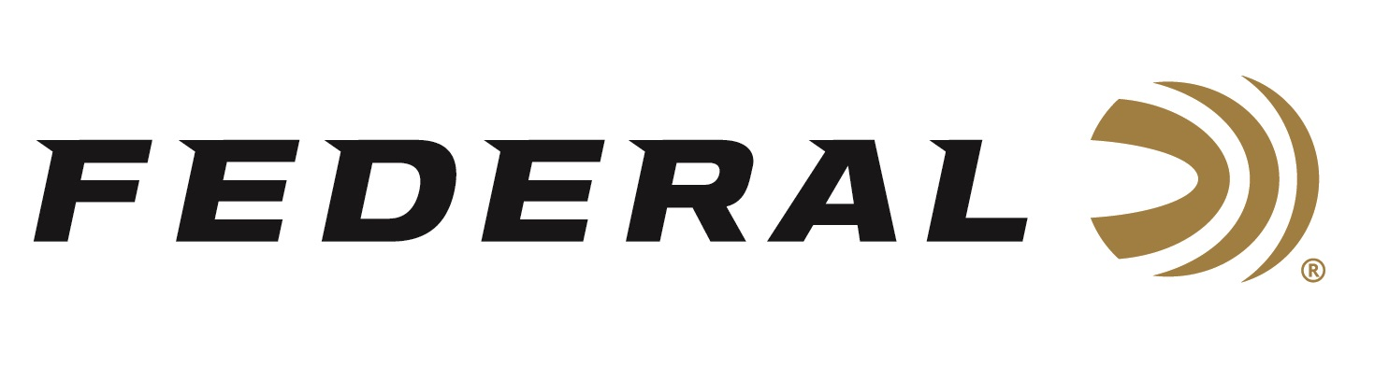
FOR IMMEDIATE RELEASE

Federal Ammunition Sponsored Shooters Set Multiple New Records at the Recent World Speed Shooting Championships

ANOKA, Minnesota – October 1, 2020 – Team Federal/CCI had an excellent showing, setting several world records, at the recent 2020 Palmetto State Armory and Lead Star Arms World Speed Shooting Championships, presented by Federal Ammunition. The event was held September 23-27 at CMP Marksmanship Park in Talladega, Alabama.

“With almost 650 guns across 13 divisions, the fast action and exciting turn of events of this match was thrilling to watch,” said Federal’s Shooting Sports Promotions Manager Jason Spradling. “Especially from three of our Team Federal/CCI shooters—Chris Barrett, Cole Busch, and Grant Kunkel—who dominated the match and claimed four world records. All three shooters run CCI 22 LR rimfire ammunition and Federal Syntech 9mm in their match guns.”

Early in the 2020 match, Team Federal/CCI shooter Grant Kunkel set a new world record in the Rimfire Rifle Optics Division with a blistering aggregate time of 57.52 seconds. Grant’s record time was short-lived, however, as his teammate Chris Barrett beat him out, the very next day, by taking first place and setting a new world record aggregate time of 56.57 seconds in that division.

Chris Barrett went on to claim two more first place finishes while setting new world records in the PCC Optics Division with a time of 60.33, and the PCC Irons Division with a time of 59.48.

Cole Busch claimed first place while setting a new world record in the Rimfire Rifle Irons Division with a time of 58.86 seconds.

Overall, Team Federal/CCI shooters claimed 4 first-place finishes, 15 top-five finishes and 18 top-ten finishes in eight of the divisions.

For the Rifle Master Title, Barrett, Kunkel and Busch finished first, second and third, respectively. Additionally, Busch earned the title of Rimfire Master.

“I’ve been so proud of these three young men and the hard work they’ve put into their sport. They each have a focus and determination to win that will make them champions in whatever they choose to pursue,” said Spradling. “Chris, Grant and Cole have demonstrated that they are the best all-around shooters in Steel Challenge. Fortunately for us, they’re also some of the best people and I’m proud to have them on our team. We congratulate all shooters on Team Federal/CCI for a job well done.”

Federal ammunition can be found at dealers nationwide or purchased online direct from Federal. For more information on all products from Federal or to shop online, visit www.federalpremium.com.

Press Release Contact: JJ Reich
Senior Manager – Press Relations
E-mail: VistaPressroom@VistaOutdoor.com

About Federal Ammunition
Federal, headquartered in Anoka, MN, is a brand of Vista Outdoor Inc., an outdoor sports and recreation company. From humble beginnings nestled among the lakes and woods of Minnesota, Federal Ammunition has evolved into one of the world's largest producers of sporting ammunition. Beginning in 1922, founding president, Charles L. Horn, paved the way for our success. Today, Federal carries on Horn's vision for quality products and service with the next generation of outdoorsmen and women. We maintain our position as experts in the science of ammunition production. Every day we manufacture products to enhance our customers' shooting experience while partnering with the conservation organizations that protect and support our outdoor heritage. We offer thousands of options in our Federal Premium and Federal® lines-it's what makes us the most complete ammunition company in the business and provides our customers with a choice no matter their pursuit.

