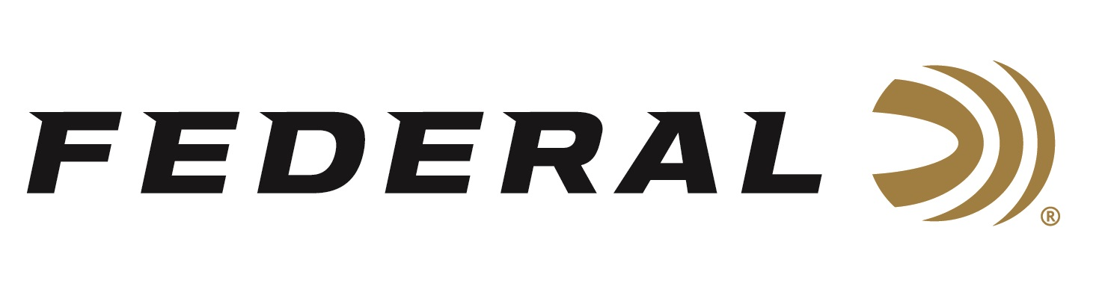

FOR IMMEDIATE RELEASE

Ready for Summer: New Federal Merchandise

ANOKA, Minnesota – July 1, 2020 – Demanded by hunters and shooters across the country, Federal Ammunition has launched a comprehensive line of high-quality branded gear for sale direct to consumer, alongside the company’s ammunition products. The new merchandise includes men’s and women’s apparel, home décor, hunting and range gear, educational tools, gifts and more, featuring exclusive products from Federal’s partners such as Black Rifle Coffee Company, Duluth Pack and others.

“Federal Ammunition’s products have been making a name for themselves at the range and in the field since 1922,” said Federal’s Vice President of Marketing Jason Nash. “Our ammunition has made a lasting connection with Federal fans who want to make our brand part of their everyday lifestyle. Now, our consumers can show off the Shockwave like never before with a full new line of Federal-branded products.”

Federal’s new line of branded merchandise has something for every hunter and shooter. For example, Federal fans can gear up for their next range day with Federal paper target packs, ammo storage boxes, and, for a limited time, an exclusive line of apparel showing support for USA Shooting.

Product Highlights for July 2020
- Federal Target 10 Pack
https://www.federalpremium.com/merchandise/gear/2198053.html
- Prairie Storm Ammo Box
https://www.federalpremium.com/merchandise/gear/2238848.html
- Federal/USA Shooting T-Shirt
https://www.federalpremium.com/merchandise/apparel/short-sleeve-shirts/2194395.html

With new items added frequently alongside exciting sales and promotions, customers are encouraged to check https://www.federalpremium.com/merchandise/ regularly to see what’s new.

Federal ammunition can be found at dealers nationwide or purchased online direct from Federal. For more information on all products from Federal or to shop online, visit www.federalpremium.com.

Press Release Contact: JJ Reich
Senior Manager – Press Relations
E-mail: VistaPressroom@VistaOutdoor.com

About Federal Ammunition
Federal, headquartered in Anoka, MN, is a brand of Vista Outdoor Inc., an outdoor sports and recreation company. From humble beginnings nestled among the lakes and woods of Minnesota, Federal Ammunition has evolved into one of the world's largest producers of sporting ammunition. Beginning in 1922, founding president, Charles L. Horn, paved the way for our success. Today, Federal carries on Horn's vision for quality products and service with the next generation of outdoorsmen and women. We maintain our position as experts in the science of ammunition production. Every day we manufacture products to enhance our customers' shooting experience while partnering with the conservation organizations that protect and support our outdoor heritage. We offer thousands of options in our Federal Premium and Federal® lines-it's what makes us the most complete ammunition company in the business and provides our customers with a choice no matter their pursuit.

