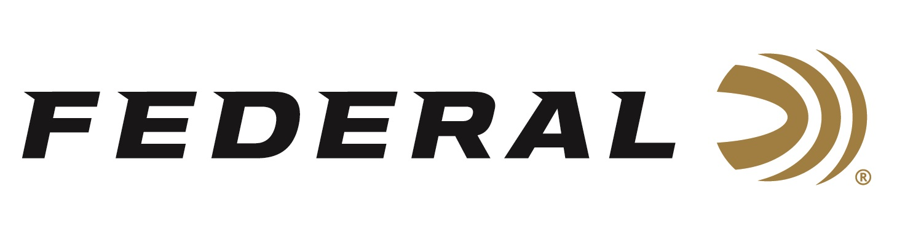

FOR IMMEDIATE RELEASE

Shotgun Shooters on Team Federal Shine at the 2020 World Skeet Championships

ANOKA, Minnesota – October 19, 2020 – The list of Team Federal competition wins during the 2020 World Skeet Championships at the National Shooting Complex in San Antonio, Texas was impressive. Team Federal made another good showing with three members of the team taking home notable wins.

Jason Ward won the World Champion title in the 28-gauge division of the 2020 Main World Skeet Championships. Ward also was the HAA Champion, and Runner-up in the Doubles division of the 2020 Mini World Skeet Championships.

Paul Giambrone was named World Champion in the Champion of Champions event. He was also Runner-up in the 20-gauge division and took second in the HAA 12-gauge division of the 2020 Main World Skeet Championships.

Stuart Brown earned the honor of Champion in the 12-gauge division of the 2020 Mini World Skeet Championships.

Other Team Federal won awards in several World Events as well. Those examples included Houston Deshotels winning awards in the Doubles, 12-gauge and HAA standard divisions; Mark Valincourt in the 410 division (Standard); Cameron Schuster in the Doubles division (Mini); and more.

“We congratulate all the shooters on Team Federal who participated at these Championships,” said Vice President of Marketing Jason Nash. “Their performances were outstanding, we know they had fun, plus their accomplishments and personal experiences are a great endorsement for our reliable and effective products.”

Federal is the official shotshell ammunition sponsor and supplier of USA Shooting, a non-profit organization that promotes the shooting sports and prepares American athletes to bring home gold. Federal is also a large supporter of the Amateur Trap Association (ATA), National Skeet Shooters Association (NSSA), National Sporting Clays Association (NSCA), and many other national, regional and state shooting sports organizations.

Federal ammunition can be found at dealers nationwide or purchased online direct from Federal. For more information on all products from Federal or to shop online, visit www.federalpremium.com.

Press Release Contact: JJ Reich
Senior Communications Manager - Firearms and Ammunition
E-mail: VistaPressroom@VistaOutdoor.com

About Federal Ammunition
Federal, headquartered in Anoka, MN, is a brand of Vista Outdoor Inc., an outdoor sports and recreation company. From humble beginnings nestled among the lakes and woods of Minnesota, Federal Ammunition has evolved into one of the world's largest producers of sporting ammunition. Beginning in 1922, founding president, Charles L. Horn, paved the way for our success. Today, Federal carries on Horn's vision for quality products and service with the next generation of outdoorsmen and women. We maintain our position as experts in the science of ammunition production. Every day we manufacture products to enhance our customers' shooting experience while partnering with the conservation organizations that protect and support our outdoor heritage. We offer thousands of options in our Federal Premium and Federal® lines-it's what makes us the most complete ammunition company in the business and provides our customers with a choice no matter their pursuit.

