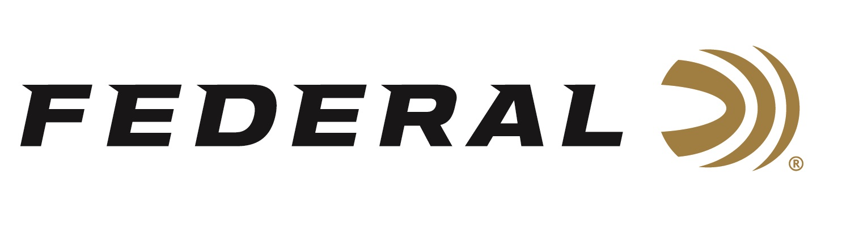

FOR IMMEDIATE RELEASE

Federal Announces New Handgun Ammunition for 2021

ANOKA, Minnesota – January 20, 2021 – Federal Ammunition’s product teams are expanding handgun cartridge options in multiple product categories in 2021. Several new product line extensions in Hydra-Shok Deep, Punch, Syntech Range and more will be manufactured and delivered to dealers throughout the year. New-for-2021 product launch highlights include:

Hydra-Shok Deep in 380 Auto and 38 Special – These loads unlock the potential of smaller cartridges. They utilize Hydra-Shok Deep’s robust center post and compact core to consistently penetrate beyond the FBI-recommended 12-inch minimum through bare gel and heavy clothing.

Punch in 22 LR and 10mm Auto - Punch 22 LR uses a deep-penetrating bullet that makes the popular rimfire cartridge a viable self-defense option, while the 10mm Auto load’s jacketed hollow point produces the best expansion and penetration in the category.

Swift A-Frame JHP in 327 Federal Magnum and 10mm Auto – The A-Frame Jacketed Hollow Point bullet has a bonded front half which expands consistently across a broad velocity range, while the back half remains intact for deep penetration. This bullet is ideal for hunting with handguns.

Syntech Range in 380 Auto, 38 Special and 10mm Auto - Syntech Range loads use the TSJ polymer jacket to eliminate metal fouling and drastically reduce damaging barrel heat and friction. Syntech ammunition offers a smoother, cleaner and safer experience when training and having fun at the range.

“In addition to launching new 2021 products, we are also continuing to stay focused on marketing the new products launched a year ago, such as our Solid Core and American Eagle IRT Lead Free ammo,” said Federal's Handgun Product Line Manager Chris Laack. “Solid Core is intended for hunting and protection against dangerous animals. The deep-penetrating, hard Solid Core bullet holds together while blowing through bone, and its Syntech jacket reduces friction and leading. American Eagle IRT utilizes lead-free bullets and the Catalyst lead-free primer to offer the same shelf life and ballistics of conventional range ammo. It’s an ideal solution for those shooting at an indoor range that requires lead-free ammunition.”

Federal ammunition can be found at dealers nationwide or purchased online direct from Federal. For more information on all products from Federal or to shop online, visit www.federalpremium.com.

Press Release Contact: JJ Reich
Senior Manager – Press Relations
E-mail: VistaPressroom@VistaOutdoor.com

About Federal Ammunition
Federal, headquartered in Anoka, MN, is a brand of Vista Outdoor Inc., an outdoor sports and recreation company. From humble beginnings nestled among the lakes and woods of Minnesota, Federal Ammunition has evolved into one of the world's largest producers of sporting ammunition. Beginning in 1922, founding president, Charles L. Horn, paved the way for our success. Today, Federal carries on Horn's vision for quality products and service with the next generation of outdoorsmen and women. We maintain our position as experts in the science of ammunition production. Every day we manufacture products to enhance our customers' shooting experience while partnering with the conservation organizations that protect and support our outdoor heritage. We offer thousands of options in our Federal Premium and Federal lines-it's what makes us the most complete ammunition company in the business and provides our customers with a choice no matter their pursuit.

