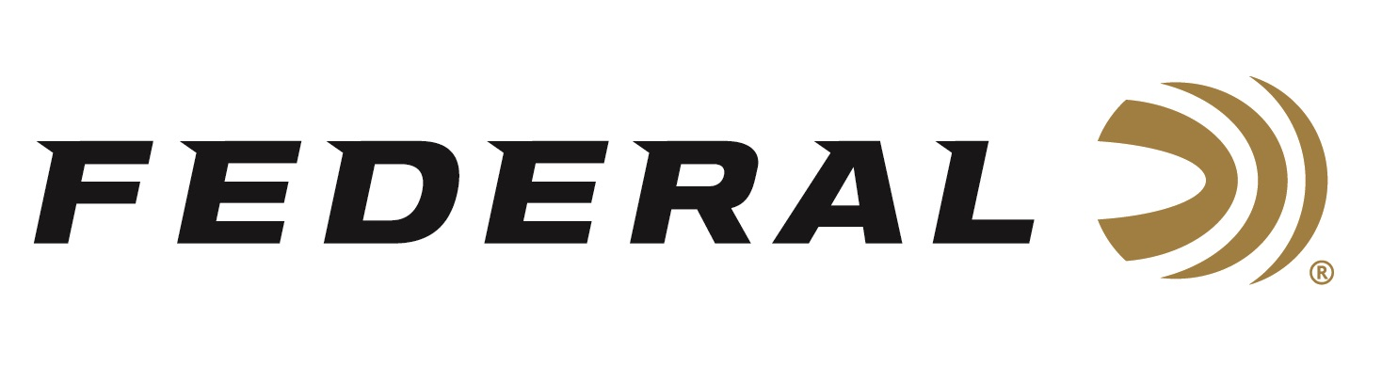

FOR IMMEDIATE RELEASE

Federal Awarded 5.56mm NATO Service and Training Ammunition Contract for the DOJ, FBI

ANOKA, Minnesota – January 27, 2021 – The Department of Justice (DOJ) - Federal Bureau of Investigation (FBI) has selected Vista Outdoor’s Federal Ammunition brand as the primary awardee for their 5.56mm NATO Service and Training, Reduced-Lead Ammunition. This multiple-award, Indefinite Delivery, Indefinite Quantity contract is for an ordering period totaling five years with product delivery beginning in April of 2021.

“Federal continues to be honored that the most trusted law enforcement agencies both domestically and internationally continue to believe and value the products we make,” said Federal’s President Jason Vanderbrink. “It’s a solid validation of the technology and performance found in every round of ammunition made by our highly skilled American workforce.”

The FBI is the federal government's principal agency responsible for investigating violations of more than 260 Federal statutes. For this award, they selected a service round utilizing Federal Ammunition’s tactical bonded technology. The Tactical Bonded line is a trusted partner for some of the most intense conditions. Made exclusively for law enforcement, it achieves reliability, terminal performance, and accuracy paramount to the survival of special agents and others in the face of violent confrontation.

“This is a very prestigious award and substantiates Federal’s reputation as the manufacturer of the market’s most advanced rifle ammunition. From service to training, Federal offers the best rifle rounds for supporting the specified mission,” said David Leis, Federal’s VP of Law Enforcement, Government and International Sales. “The training round selected is designed with one of the most accurate bullets in the market. The cartridge is configured to replicate duty performance, so agents’ training experiences are authentic to their duty expectations.”

Federal ammunition can be found at dealers nationwide or purchased online direct from Federal. For more information on all products from Federal or to shop online, visit www.federalpremium.com.

Press Release Contact: JJ Reich
Senior Manager – Press Relations
E-mail: VistaPressroom@VistaOutdoor.com

About Federal Ammunition
Federal, headquartered in Anoka, MN, is a brand of Vista Outdoor Inc., an outdoor sports and recreation company. From humble beginnings nestled among the lakes and woods of Minnesota, Federal Ammunition has evolved into one of the world's largest producers of sporting ammunition. Beginning in 1922, founding president, Charles L. Horn, paved the way for our success. Today, Federal carries on Horn's vision for quality products and service with the next generation of outdoorsmen and women. We maintain our position as experts in the science of ammunition production. Every day we manufacture products to enhance our customers' shooting experience while partnering with the conservation organizations that protect and support our outdoor heritage. We offer thousands of options in our Federal Premium and Federal® lines-it's what makes us the most complete ammunition company in the business and provides our customers with a choice no matter their pursuit.

