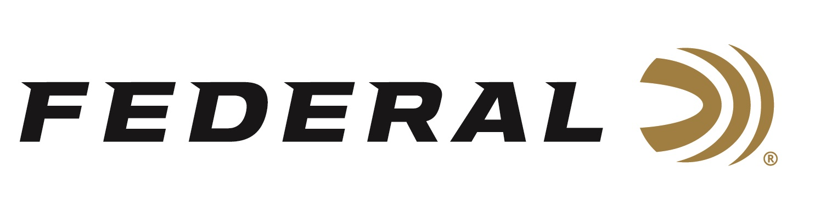

FOR IMMEDIATE RELEASE

Federal Ammunition Introduces New 22 LR Punch Personal Defense

ANOKA, Minnesota – April 14, 2021 – Different shooters have different needs, different limitations, and different firearms. Yet for all those variables, 22 Long Rifle has never really been an option for personal defense—until now. Federal Premium introduces Punch 22 LR, a new load using a first-of-its-kind 29-grain nickel-plated lead-core bullet, pushed at maximum velocities for the deepest penetration through short-barrel handguns. Shipments of this product have begun to arrive at dealers.

“Self-defense isn’t one size fits all. So, whether shooters want to carry a 22 LR handgun as a backup gun, do not feel comfortable with centerfire pistols, or simply want to get more versatility from a rimfire handgun,” said Federal’s Rimfire Product Manager, Dan Compton, “Punch makes the 22 LR cartridge a viable defensive choice for the first time ever.”

The Punch 22 LR bullet is a departure from standard 22 LR design. It features a flat nose and utilizes a heavy nickel-plated jacket around a lead core. So not only does it travel faster than competing 22 projectiles, but its design also deliberately minimizes expansion and retains weight to maintain sufficient straight-line penetration. That is a lot to ask from a .22 bullet, which is why other manufacturers have shied away from the challenge. But Federal’s engineering team pulled it off, giving America’s favorite cartridge a chance to prove itself for protection.

“We’ve talked about making a 22 LR defensive load for some time. We finally decided that people are already carrying 22 LRs, so we might as well build a .22 bullet optimized for protection,” said Compton. “After much research, we decided that for a .22 LR defense bullet, penetration was more important than expansion.”

Features & Benefits
- Maximum velocity for energy and penetration; 1,070 fps through 2-inch barrel handguns, 1,650 fps out of 24-inch rifle barrels
- 29-grain nickel-plated lead-core bullet
- Projectile profile and composition optimized for the deepest penetration through short-barrel handguns
- Rigorous function testing ensures reliability
- Nickel-plated case for ease of extraction and corrosion resistance
- 50-count boxes
Part No. / Description / MSRP
PD22L1 / 22 LR Punch Personal Defense 29GR FN, 50CT / $9.99

For more information on all products from Federal or to shop online, visit www.federalpremium.com.

Press Release Contact: JJ Reich
Senior Manager – Press Relations
E-mail: VistaPressroom@VistaOutdoor.com

About Federal Ammunition
Federal, headquartered in Anoka, MN, is a brand of Vista Outdoor Inc., an outdoor sports and recreation company. From humble beginnings nestled among the lakes and woods of Minnesota, Federal Ammunition has evolved into one of the world's largest producers of sporting ammunition. Beginning in 1922, founding president, Charles L. Horn, paved the way for our success. Today, Federal carries on Horn's vision for quality products and service with the next generation of outdoorsmen and women. We maintain our position as experts in the science of ammunition production. Every day we manufacture products to enhance our customers' shooting experience while partnering with the conservation organizations that protect and support our outdoor heritage. We offer thousands of options in our Federal Premium and Federal® lines-it's what makes us the most complete ammunition company in the business and provides our customers with a choice no matter their pursuit.

