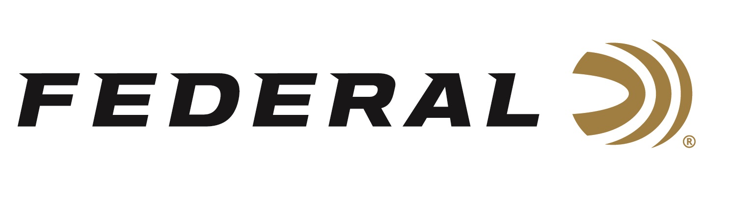

FOR IMMEDIATE RELEASE

Ballistic’s Best Magazine Recognized Federal Premium’s Force X2 and Practice & Defend Ammunition with Editor’s Selects Awards

ANOKA, Minnesota – February 4, 2021 – Ballistic’s Best magazine recently recognized Federal’s Force X2 and Practice & Defend Packs with Editor’s Selects Awards for the best new shotgun and handgun ammunition from the previous year. The awards were announced in the publication’s recent December 2020 / January 2021 issue.

“The editorial staff at Ballistic’s Best is certainly well-versed on all of the latest and greatest guns and ammunition,” said Jason Nash, Federal’s Vice President of Marketing. “We know the publication’s Editor’s Selects winners are chosen based on a lot of actual hands-on testing by dozens of their expert content creators. We are proud and excited that our Force X2 and Federal Practice & Defend Packs were recognized with these two awards.”

Winning the Best Shotgun Ammo category, Federal Force X2 is a 12-gauge, 2¾-inch, nine-pellet segmenting buckshot. Its nine copper-plated 00 FX2 buckshot pellets are engineered to split into two equally sized pieces upon impact. This creates up to 18 wound channels, improves the transfer of energy from the payload to the target and minimizes the potential for overpenetration. Force X2 is also loaded for more manageable recoil; this allows the shooter to stay on target for quicker follow-ups and better accuracy in self-defense situations.

Winning the Best Handgun Ammo category, Federal Practice & Defend Packs (available in 9mm, .40 S&W and .45 ACP) take all of the guesswork out of matching your training and defensive rounds. Each pack includes 50 self-defense HST rounds and 50 Syntech Training Match rounds. Federal designed both loads to produce identical velocities, trajectories and points of impact. This combo pack pairs the self-defense load proven by law enforcement with the industry’s most complete training ammunition for a combination like no other.

Federal ammunition can found at dealers nationwide or purchased online direct from Federal. For more information on all products from Federal or to shop online, visit www.federalpremium.com.

Press Release Contact: JJ Reich
Senior Communications Manager - Ammunition
E-mail: VistaPressroom@VistaOutdoor.com

About Federal Ammunition
Federal, headquartered in Anoka, MN, is a brand of Vista Outdoor Inc., an outdoor sports and recreation company. From humble beginnings nestled among the lakes and woods of Minnesota, Federal Ammunition has evolved into one of the world's largest producers of sporting ammunition. Beginning in 1922, founding president, Charles L. Horn, paved the way for our success. Today, Federal carries on Horn's vision for quality products and service with the next generation of outdoorsmen and women. We maintain our position as experts in the science of ammunition production. Every day we manufacture products to enhance our customers' shooting experience while partnering with the conservation organizations that protect and support our outdoor heritage. We offer thousands of options in our Federal Premium and Federal® lines-it's what makes us the most complete ammunition company in the business and provides our customers with a choice no matter their pursuit.

###

