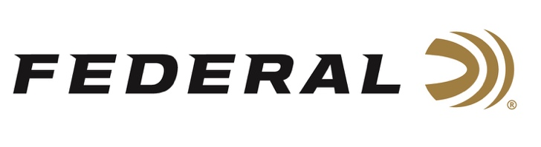

FOR IMMEDIATE RELEASE

Team Federal Shines at the 2021 Fort Benning Multigun Challenge

ANOKA, Minnesota – December 1, 2021 – Team Federal sponsored shooters finished strong at the recent 2021 Fort Benning Multigun Challenge in Fort Benning Georgia. Every fall, the U.S. Army hosts this event at the fort’s recreational shooting complex. Federal supported this year’s match as a Gold Sponsor. Team Federal shooters Tucker Schmidt, Alysia Burrows and Todd Jarrett all performed well among the 234 shooters on hand. Schmidt earning a second-place finish for the match shooting in the Open division, Burrows with second place in the Tac Ops division for the Ladies’ category, and Jarrett finishing in eighth place for the Tac Ops division also earning “Top Senior” for the match.

“Congratulations to all our shooters at this match. The Army Marksmanship Unit are famous for running fun, innovative matches. From all I’ve heard, this one was no exception,” said Federal Ammunition Shooting Sports Promotions Manager Jason Spradling. “Our Team Federal shooters always do a great job representing our brand and I’m proud of their achievements this weekend.”

“It was a close and heated competition. It came down to the very last stage and it didn’t go my way. I’ll be working hard to come back next year and get the win,” said Schmidt.
“My go-to ammo is The Federal Gold Medal line of shotgun and precision rifle ammo, as well as the American Eagle 55-grain for the go-fast rifle portions.”

“In a stiff competition environment like Benning, there really isn’t any margin for error. That’s why knowing your guns and knowing your ammo is a big part of preparation for an event like this,” said Burrows. “Feeding high performance guns with questionable ammo isn’t an option. I’ve always used Federal, even before I was on the team. I know each round is going to perform the same as the last.”

“Todd Jarrett’s Top Senior trophy and top-ten finish certainly was a highlight of the event for Team Federal,” continued Spradling. “Todd is a seasoned competitor and is well respected in the community. We’re excited to have him on board representing our brand with solid performances like this one.”

For more information on all products from Federal or to shop online, visit www.federalpremium.com.

Press Release Contact: JJ Reich
Senior Manager – Press Relations
E-mail: VistaPressroom@VistaOutdoor.com

About Federal Ammunition
Federal, headquartered in Anoka, MN, is a brand of Vista Outdoor Inc., an outdoor sports and recreation company. From humble beginnings nestled among the lakes and woods of Minnesota, Federal Ammunition has evolved into one of the world's largest producers of sporting ammunition. Beginning in 1922, founding president, Charles L. Horn, paved the way for our success. Today, Federal carries on Horn's vision for quality products and service with the next generation of outdoorsmen and women. We maintain our position as experts in the science of ammunition production. Every day we manufacture products to enhance our customers' shooting experience while partnering with the conservation organizations that protect and support our outdoor heritage. We offer thousands of options in our Federal Premium and Federal® lines-it's what makes us the most complete ammunition company in the business and provides our customers with a choice no matter their pursuit.

###

