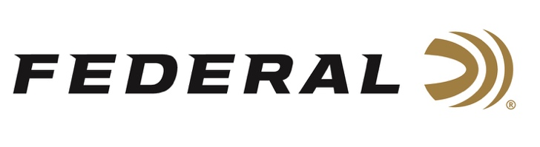

FOR IMMEDIATE RELEASE

Holly Collects More Top Gas Gun Hardware

ANOKA, Minnesota – December 9, 2021 – Team Federal Precision Rifle Series shooter Buck Holly starts the season off right with an impressive performance at the first PRS Pro Series match of the 2022 season. The MPA Fall Shootout was held December 4-5, 2021 at Cool Acres Sporting Camp in Swainsboro, GA. With more than 110 shooters in attendance, Holly took home the top trophy in the Gas Gun category and was a PRS Skills Stage winner.

“The PRS is experiencing incredible growth and I’m proud to be part of an inclusive organization that supports ALL shooters. My personal success stems from my family and the support they provide me along with extraordinary support provided by my sponsors” say Holly. In his Skills Stage victory, Holly won with an impressive time of 33.91 seconds that included hitting 8 of 8 targets from four positions at a 10-inch plate at 400 yards.

Holly, who hails from Richmond Hill, Georgia, uses Federal Gold Medal 6mm Creedmoor factory ammunition loaded with 105-grain Berger Hybrid bullets in his GA Precision MSR-style rifle when competing. “Our team’s consistent high performance is testament to the quality and accuracy of our Federal Gold Medal line.” says Federal Shooting Sports Promotions Manager Jason Spradling. “We’re excited to see Buck starting off the ’22 season with another strong performance.”

For more information on all products from Federal or to shop online, visit www.federalpremium.com.

Press Release Contact: JJ Reich
Senior Manager – Press Relations
E-mail: VistaPressroom@VistaOutdoor.com

About Federal Ammunition
Federal, headquartered in Anoka, MN, is a brand of Vista Outdoor Inc., an outdoor sports and recreation company. From humble beginnings nestled among the lakes and woods of Minnesota, Federal Ammunition has evolved into one of the world's largest producers of sporting ammunition. Beginning in 1922, founding president, Charles L. Horn, paved the way for our success. Today, Federal carries on Horn's vision for quality products and service with the next generation of outdoorsmen and women. We maintain our position as experts in the science of ammunition production. Every day we manufacture products to enhance our customers' shooting experience while partnering with the conservation organizations that protect and support our outdoor heritage. We offer thousands of options in our Federal Premium and Federal® lines-it's what makes us the most complete ammunition company in the business and provides our customers with a choice no matter their pursuit.

###

