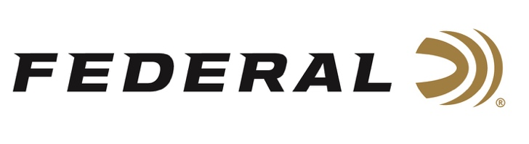

FOR IMMEDIATE RELEASE

Buck Holly Takes Top Gas Gun Category at the 3rd Annual Federal Gold Medal PRS Match

ANOKA, Minnesota – September 15, 2021 – Team Federal Precision Rifle Series shooter Buck Holly finished strong in the 3rd Annual Federal Gold Medal PRS Match. The event was held at Alabama Precision in Carbon Hill, Alabama, September 11-12. With 140 shooters in attendance, Holly took home the top trophy in the Gas Gun category and placed eleventh overall during this two-day PRS Pro Series Qualifier match.

“Buck is a hardcore competitor. He has the experience and grit to shoot well in spite of adverse conditions,” said Federal Shooting Sports Promotions Manager Jason Spradling. “It was a lot of fun to watch his performance and I’m proud that Federal Gold Medal ammunition was part of the equation.”

Holly, who hails from Richmond Hill, Georgia, uses Federal Gold Medal 6mm Creedmoor factory ammunition loaded with 105-grain Berger Hybrid bullets in his GA Precision MSR-style rifle when competing.

“This may be my all-time favorite ammo and rifle combination. With my Federal ammo, this rifle absolutely hammers,” said Holly. “People underestimate the potential of gas guns and factory ammunition, but I’ll put this combination up against anything in the country. I was able to perform well with it despite the heat and switching winds, and I was happy with the results.”

“Match Director Jim Saunders and the Alabama Precision crew developed a challenging course of fire. However, a tail wind that varied in both speed and direction during the entire weekend made the match even more difficult, yet exciting to watch,” continued Spradling. “We at Federal, were very pleased to have had the opportunity to sponsor this match for the third consecutive year. This match has become one of the most popular matches in the country due, in large part, to the efforts of Saunders and his team. We’re looking forward to sponsoring this match for years to come.”

For more information on all products from Federal or to shop online, visit www.federalpremium.com.

Press Release Contact: JJ Reich
Senior Manager – Press Relations
E-mail: VistaPressroom@VistaOutdoor.com

About Federal Ammunition
Federal, headquartered in Anoka, MN, is a brand of Vista Outdoor Inc., an outdoor sports and recreation company. From humble beginnings nestled among the lakes and woods of Minnesota, Federal Ammunition has evolved into one of the world's largest producers of sporting ammunition. Beginning in 1922, founding president, Charles L. Horn, paved the way for our success. Today, Federal carries on Horn's vision for quality products and service with the next generation of outdoorsmen and women. We maintain our position as experts in the science of ammunition production. Every day we manufacture products to enhance our customers' shooting experience while partnering with the conservation organizations that protect and support our outdoor heritage. We offer thousands of options in our Federal Premium and Federal® lines-it's what makes us the most complete ammunition company in the business and provides our customers with a choice no matter their pursuit.

###

